

Rural Accommodation and Infrastructure
Photos

Purchase of Portland student accommodation
Accommodation photos
Photos 1 and 2: Front and back entries to the property
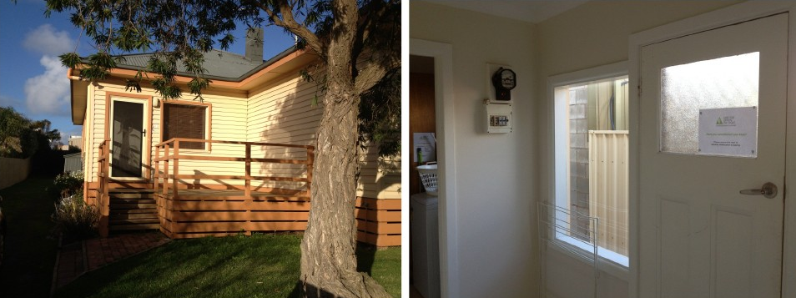
Photos 3 and 4: Bathroom
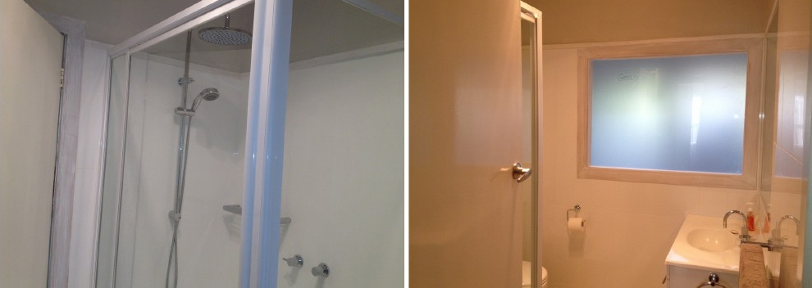
Photos 5 and 6: Kitchen/dining room
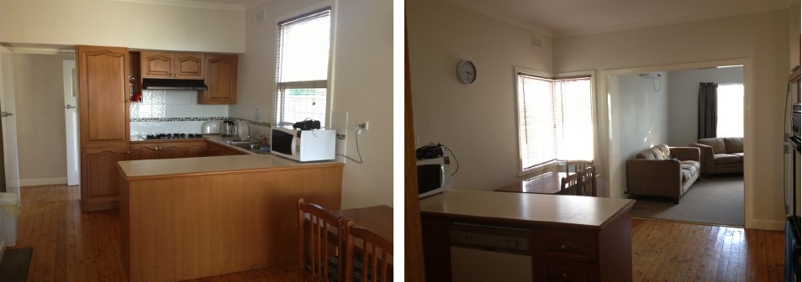
Photos 7 and 8: Lounge room/laundry
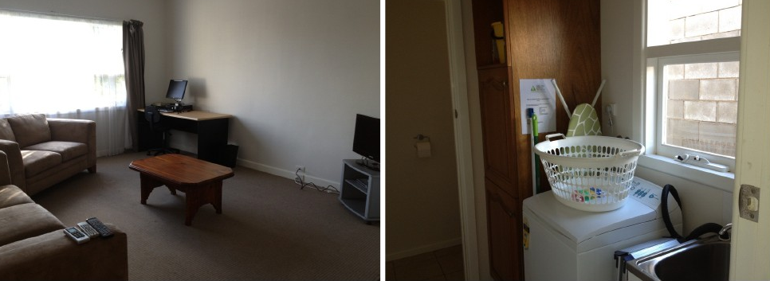
Photos 9 and 10: Bedroom one and two
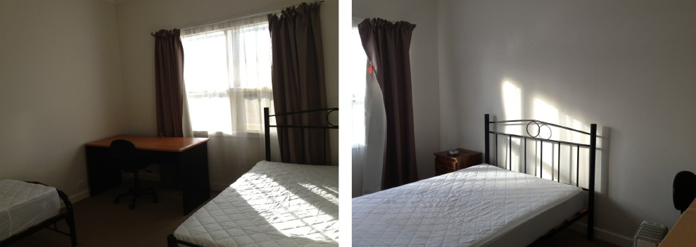
Photo 11: Bedroom three


