Introduction to Student Supervision Training

The Introduction to Student Supervision workshop will assist you to build a learning culture within your organisation. Flexibility exists to adapt the workshop to the particular needs of your staff and organisation.

This Northern Metropolitan Clinical Placement Network (NMCPN) project was set up to support health professionals develop the skills and confidence needed to provide high quality supervision to students on placement.

MODULE | CONTENT
Fostering clinical reasoning | Module 3 defines the process of clinical reasoning. It describes and exemplifies the process of clinical reasoning, modelling a positive professional attitude and a capacity for self reflection.  Modelling communication, teamwork and leadership skills and promoting technical skills and capacity for clinical reasoning.



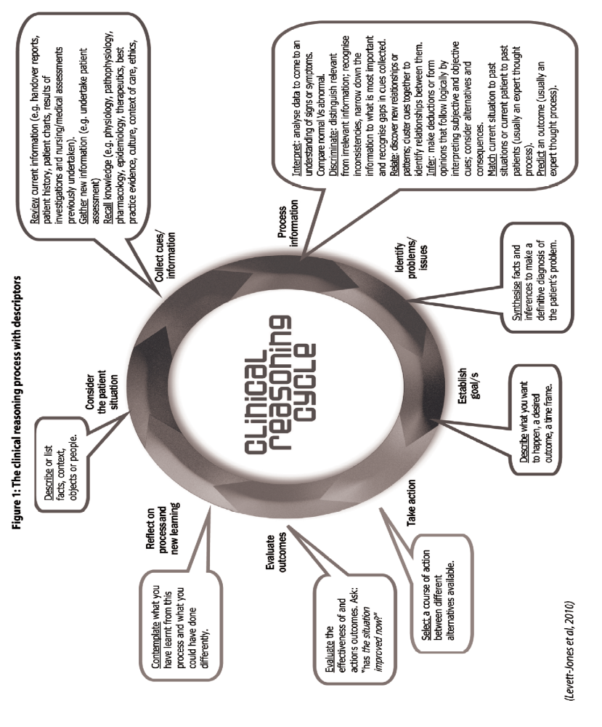

Clinical Reasoning — a practice example (Allied Health)

Description

Describe as a matter of fact what happened during your critical incident or chosen episode for reflection

I was treating a patient with vascular dementia on the ward. I went to get him for therapy but he refused, instead insisting on going to the toilet. I asked him to wait until I got a nurse because he required a minimum of two assist to get out of bed. He then became agitated and attempted to get out of bed. When I asked him to wait until the nurse arrived to help, he became very aggressive. There were no other people in the room. The patient was leaning toward me and talking in a threatening manner, making personal derogatory remarks. He attempted to get out of bed again and fell. I then pressed the buzzer to call assistance. When the nurse arrived, we helped the patient back into bed and called the registrar to check him over. At that time I was asked to leave the room by the registrar and nurse.

Feelings

What were you thinking and feeling at the time?

I was very concerned about the safety of the patient because he fell, about my safety
because of the level of aggression displayed towards me as well as my inability to manage the situation. When it was happening I was thinking that I needed to terminate the session as quickly as possible and get help but I felt stuck and I panicked. I was telling myself that I needed to stay in control, but I felt the situation was out of control.

Evaluation

List the points or tell the story about what was good and what was bad about the
experience

I am surprised I was able stay in the room and not burst into tears. I attempted to settle the patient down to the point where I could leave him to get help but I was unsuccessful. Distracting him seemed to work only for a short while. I should have pressed the buzzer earlier. I felt guilty that he fell and embarrassed that I did not think quickly enough on my feet to press the buzzer.
‘Critical reflection requi

Process | Description | Example
Consider the patient situation | Describe or list facts, context, objects or people. | This 60 year old patient is in ICU because he had an abdominal aortic aneurysm (AAA) surgery yesterday
Collect cues/  information | Review current information (e.g. handover reports, patient history, patient charts, results of investigations and nursing/medical assessments previously undertaken) | He has a history of hypertension and he takes beta blockers  His BP was 140/80 an hour ago
Collect cues/  information | Gather new information (e.g. undertake patient assessment) | I’ve checked his BP and it is now 110/60, Temp 384.  Epidural running @ 10ml/hr
Collect cues/  information | Recall knowledge (e.g. physiology, pathophysiology, pharmacology, epidemiology, therapeutics, culture, context of care, ethics, law etc)
Process information | Interpret analyse data to come to an understanding of signs or symptoms. Compare normal Vs abnormal. | His BP is low, especially for a person who is normally hypertensive
Process information | Discriminate distinguish relevant from irrelevant information; recognise inconsistencies, narrow down the information to what is most important and recognise gaps in cues collected | His temp is up a bit but I’m not too worried about it – I’m more concerned about his BP and pulse.  I’d better check his urine output and his O2 sats
Process information | Relate discover new relationships or patterns; cluster cues together to identify relationships between them.
Process information | Infer make deductions or form opinions that follow logically by interpreting subjective and objective cues; consider alternatives and consequences.
Process information | Match current situation to past situations or current patient to past patients (usually an expert thought process) | AAA’s often have hypotension post op
Process information | Predict an outcome (usually an expert thought process) | If I don’t give him more fluids he could go into shock.
Identify problem / issue | Synthesise facts and inferences to make a definitive diagnosis of the  patient problem. | He is hypovolaemic and the epidural has worsened the BP by causing vasodilation.
Establish goals | Describe what you want to happen, a desired outcome, a time frame. | I want to improve his haemodynamic status – get his BP up and urine output back to normal over the next hour.
Take action | Select a course of action between different alternatives available | I will ring the doctor to get an order to increase his IV rate and to give aramine if needed.
Evaluate | Evaluate the effectiveness of outcomes and actions. Ask: “has the situation improved now?” | His BP is up for now but we will need to keep an eye on it as he may still need aramine a bit later. His urine output is averaging > 30mL/hr now.
Reflect on process and new learning | Contemplate what you have learnt from this process and what you could have done differently. | Next time I would …  I should have …  If I had …  I now understand …

The phases of the clinical reasoning process with acute nursing examples

Questions to assist reflection/clinical reasoning

In discipline specific groups, devise some questions to assist the different types of reasoning relevant to your area.

Procedural Reasoning | E.g. What are the symptoms?
Interactive Reasoning | E.g. What are the client’s priorities?
Conditional Reasoning | E.g. How does the client’s other medical conditions influence the intervention?
Pragmatic Reasoning | E.g. Can the client afford it?
Narrative Reasoning | E.g. Do other health professionals have the same opinion?

Strategies promoting critical thinking

- Anticipate questions others might ask (e.g. What will my supervisor want to know?"). This helps you identify a wider scope of questions that must be answered to gain relevant information.

- Ask "What if" questions like, "What if something goes wrong?" or "What if we try...?" This helps you be proactive and creative.

- Look for flaws in your thinking. Ask questions like, "What's missing?”, "Have I recognized my biases?" and "How could this be made better?" This helps you evaluate your thinking and make improvements.

- Ask someone else to look for flaws in your thinking. You're usually too close to own work to be objective; others bring a fresh "eye" and may bring new ideas and perspectives.

- Develop "good habits of inquiry" (habits that aid in the search for the truth, like always keeping an open mind, verifying information, and taking enough time). These habits can make critical thinking more automatic.

- Ask questions like “What difference does it make?” For example, how will knowing the results of this diagnostic study change the plan (if it doesn’t affect the plan, maybe you don’t need to do it).

- Develop interpersonal skills like conflict resolution and getting along with those who have different communication styles. If you don't have good interpersonal skills you're unlikely to get the help or information you need to think critically.

- Replace "I don't know" and "I'm not sure" with "I'll find out". This demonstrates you have the ability to find answers and mobilizes you to locate resources.

- Turn errors into learning opportunities. We all make mistakes: They're steppingstones to maturity and new ideas (if you aren't making mistakes, maybe you're not trying hard enough).

- Raise the bar! Expect more of yourself and others. Open your mind, invite creativity, and improve quality and value to consumers

Acknowledgement: www.AlfaroTeachSmart.com.

