Authored by: <insert group or name>
Student guide
[insert semester and year]
Insert partner logos along bottom of page

© Monash University, La Trobe University and Castlemaine Health 2013
This work is copyright. You may modify the content of this work only for use in your organisation’s implementation of the Whole-of-System Student Placement program and for any use permitted by the Copyright Act 1968. Requests for further authorisation should be directed to the Manager, North West Rural Medical Education Unit, School of Rural Health – Bendigo, Monash University, PO Box 666 Bendigo Vic 3552 or by email to brcs@monash.edu.

Table of contents
1 Introduction to the Whole-of-System Student Clinical Placement program 5
1.1 Structure of the WoSSP program 5
1.2 Patient-centred healthcare activities 5
1.3 Key contacts for WoSSP activities 7
2 Program objectives 8
3 Guidelines for WoSSP patient and health service interactions 9
3.1 Preparation for your WoSSP home/community visits 9
3.2 Procedures for patient home visits 9
3.3 Professional conduct during home and service visits 10
3.4 Safety protocols for WoSSP home visits 10
4 University occupational health and safety, student travel and reporting hazards or incidents 12
4.1 Students driving their own vehicles 12
5 Links to discipline-specific unit assessment tasks 13
5.1 Formative assessment tasks 13
5.2 Summative assessment tasks 14
5.3 WoSSP group presentation: formative assessment task 15
6 WoSSP weekly schedule 17
7 WoSSP resources 19
8 WoSSP program evaluation 20
Appendix 1 Introductory team-building/reflection activity 21
Appendix 2 Community service visit activity 22

Introduction to the Whole-of-System Student Clinical Placement program
[Insert your health service and health educator provider partners] have established a Whole-of-System Student Placement (WoSSP) model in the [insert your local government area] local government area. The program is aligned with identified learning objectives and assessment tasks from the medical, nursing and allied health curricula.

Students from [Year 3 nursing, Year 4 medicine and allied health], already undertake clinical placements within hospital, general practice and community health settings in the [insert your local government area] local government area. The WoSSP model builds on these experiences by creating opportunities for students to follow specific patients/clients with complex chronic health conditions through the local health system.

Structure of the WoSSP program
Insert a summary of your program structure. For example:

The semester two WoSSP program will run for 10 weeks. One day per week (either Tuesday or Thursday) will be devoted to WoSSP clinical placement activities. This day will include structured small group learning with your allocated WoSSP clinical educator, home and community-based patient/client visits, health service visits, interprofessional work and self-directed learning.

Patient-centred healthcare activities
WoSSP patient-centred curriculum activities aim to benefit the patient/client participants and health services involved (as well as creating expanded learning opportunities for students). (See Figure 1 Patient-centred curriculum below.) It is possible that you may act as advocates and change agents for patients/clients through your WoSSP experiences (for example, by assisting patients/client to navigate the health/welfare system, identifying system complexities, reviewing patient/client transition to home and contributing to therapeutic relationships).

- Staff from the [insert health service] will pre-select patients/clients who have been discharged from [insert relevant service area e.g. the Hospital Admissions Risk Program] and who are interested in being involved in the WoSSP program.
- With appropriate patient/client consent the WoSSP clinical educator will allocate small interprofessional student teams to work with their pre-selected patients/clients.
- Students will meet with the [Patient Case Coordinator/key worker] in week 1 of the WoSSP program to review their allocated patient/client’s care plan. Students will then engage with their allocated patient/client in the GP consultation setting using the wave shared consultation model (see Figure 2 Wave shared consultation model on page 7), in their home environment and in other community health service environments if appropriate.

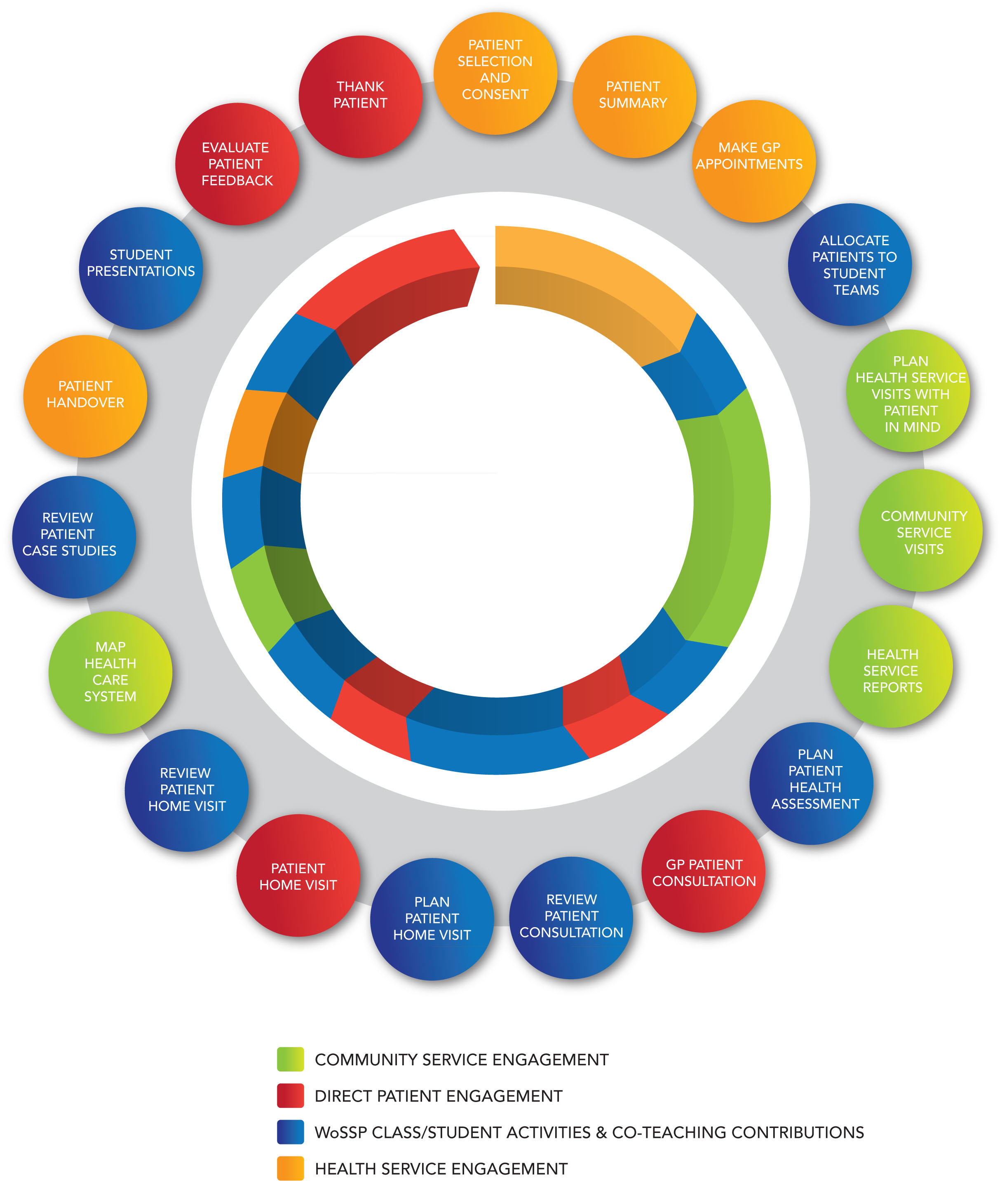
Figure 1 Patient-centred curriculum

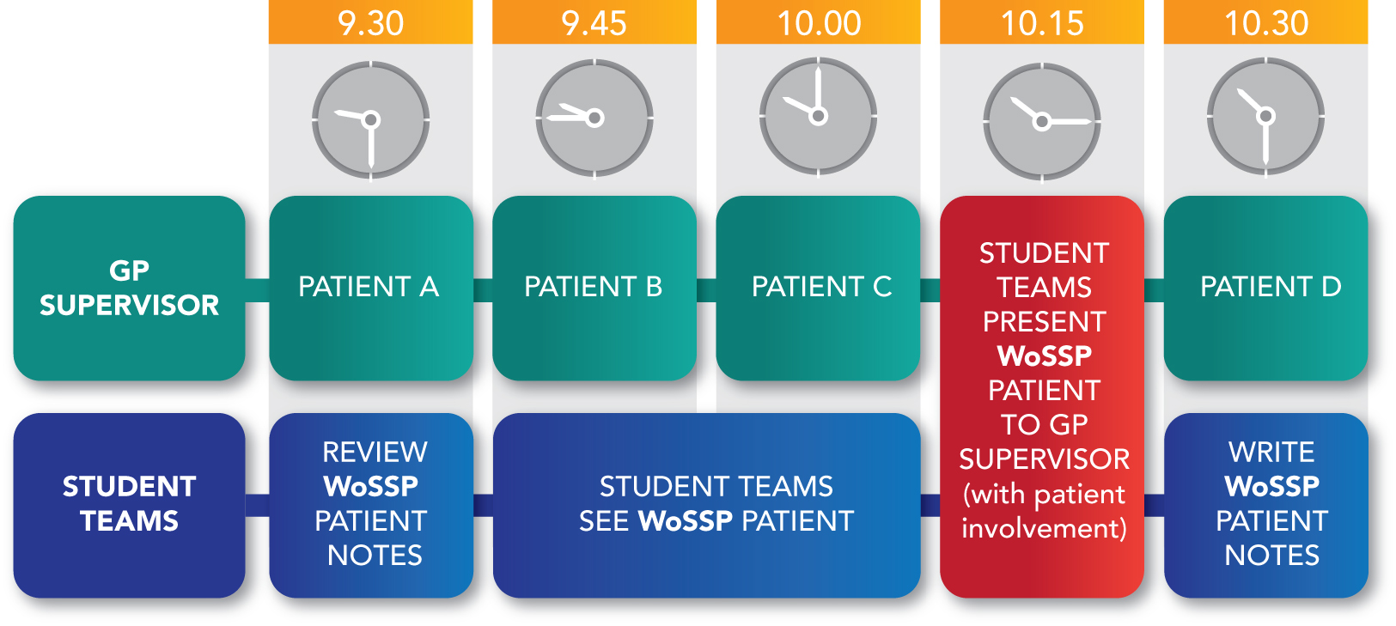
Figure 2 Wave shared consultation model

Key contacts for WoSSP activities
Insert key contact information for :
- WoSSP clinical educator
- academic staff/course coordinators for each health discipline

[name]
[position title ]
[Email]
[Telephone]

[name]
[position title ]
[Email]
[Telephone]

[name]
[position title ]
[Email]
[Telephone]
etc

Program objectives
WoSSP program objectives are aligned with core learning outcomes from the [insert details for each health education provider and health discipline group involved in WoSSP e.g. La Trobe Nursing etc] curriculum. You will also be working to achieve these objectives as part of your discipline-specific placement activities.

Insert your WoSSP program objectives for example:

On completion of the WoSSP program students should be able to:
- demonstrate appropriate communication, interpersonal and professional skills to develop effective therapeutic relationships with patients/clients, family members and significant others
- work constructively with learners and practitioners from different professions to contribute to and influence the provision of responsive and adaptive healthcare
- discuss the biological, psychological and social influences that impact on the health and wellbeing of patients/clients
- identify the ways in which people with chronic disease/disability and their families understand and deal with their health issues in the context of their lives (including the significance of a person’s narrative for intervention planning)
- identify relevant programs, services and community resources available to patient/clients and their families
- formulate and evaluate management plans appropriate for patients/clients living with complex chronic health conditions in acute and/or community-based health service settings
- analyse the local health/community service system and how it operates as a whole, including an awareness of: service system complexity; health care relationships; barriers to health care access; service strengths, gaps, duplication, innovation; client advocacy and creative solutions to service barriers
- recognise and practise within own qualifications, skills and experience including an awareness of legal and ethical practice issues.

Guidelines for WoSSP patient/client and health service interactions
As part of the WoSSP program you will have the opportunity to:
- visit patients/clients in their homes
- accompany patients/clients to appointments with other health and welfare providers
- undertake service visits.

Respectful professional practice and student safety are key priorities that underpin these visits.

Please read the following home and health service visit protocols. You must apply these consistently on every home visit and across the community.

You must also comply with the health service risk assessment protocols and procedures used by staff in your allocated placement setting when preparing for a patient/client home visit.

Preparation for your WoSSP home & community visits
All patient/client home visits and health service appointments with patients/clients must be arranged and agreed in advance in consultation with your WoSSP clinical educator and patient/client healthcare/case coordinator (including formal consent from patients/clients and health services).

Nursing and allied health students must inform the appropriate Nurse Unit Manager/clinical supervisor if they have to leave the clinical environment to participate in a WoSSP patient/client visit activity.

Procedures for patient/client home visits
- When visiting patients/clients in their home students must travel in pairs/small teams or with a qualified health professional.
- Student teams will be asked to provide their mobile contact numbers to the WoSSP clinical educator in week 1 of the WoSSP program
- On the week/s of the patient/client home visits the WoSSP clinical educator will give [insert health service contact] a WoSSP community visit contact form with student team member names, address of home visit, indication of planned appointment time and student mobile phone numbers.
- One nominated student from each WoSSP student team must ring [Insert Health Service contact area … such as local hospital reception on ph: ….] and state they are arriving at the patient/client home and names of student team members in attendance.
- The nominated student from each WoSSP team must then ring [Insert Health Service contact area… such as local hospital reception] again when they have finished the home visit and returned home or back at clinic etc.
- If there has been no response from students within two hours of the initial call confirming arrival at the patient/client’s home, the [Insert health service contact area] will call students directly. If still no contact the [receptionist] will contact the [off site risk manager] to initiate the appropriate occupational health and safety procedures.
- When conducting home or service visits your mobile phone must be charged and on your person all times (that is, in your pocket, not in a bag or in your car). Phones must be on silent or vibrate during visits and only work related/urgent calls should be accepted.

Professional conduct during home and service visits
- Wear your student name badge.
- All patient/client home visits must be purposeful, for example, to take a case history, consider home supports, assist with home assessments, meet carers, undertake a case history, gauge community connections, consider bio-psycho-social impacts, assess how the patient/client is managing and so on.
- You are to attend all home visits, patient/client appointments and service visits dressed in appropriate attire and footwear.
- Be punctual and attend all home and service visits at the time arranged.
- Remember that you are a visitor in a patient/client’s home and health services across the community. Respectful, professional behaviour is required.
- Introduce yourself to carers and people you encounter on home or service visits and explain your role and the purpose of your visit.
- Unless otherwise arranged, home and service visits should not exceed one hour.
- Students must not transport patients/clients to or from their appointments.

Safety protocols for WoSSP home visits
Student safety is the first priority. While we do not anticipate problems during patient/client home visits, some situations may occur that make you feel unsafe. We ask that you exercise caution and be mindful at all times of your own safety and the safety of those you encounter during your home visits (for example, children).

Pay particular attention to the following safety protocols:
- Do not park in the home driveway but on the street or nearby.
- Pay particular attention to the layout of any patient/client’s home you visit, for example, so you know where the front door and other exits are located.
- To avoid potential choking hazards do not wear ties, scarves, lanyards or other apparel around your neck.
- You are not to conduct any clinical work with patients/clients at any time when unsupervised.
- If a medical emergency occurs during a home visit, call 000. Students are to stay with the patient/client until an ambulance arrives and then report the incident to the WoSSP clinical educator.
- While it is anticipated that home visits will run smoothly, if you feel unsafe for any reason leave the premises immediately, return to [insert health service] and report your concern to the WoSSP clinical educator. Some examples where a student may not feel safe can include: where the patient or people within the home are drug or alcohol affected, aggressive people/patients/clients within the home and inappropriate conduct by a patient/client or other person within the home environment.
- In the unlikely event that a safety concern arises and you feel your physical safety is threatened, vacate the premises immediately and call 000 for police assistance (do not wait for the police to arrive). Return immediately to [insert health service]and report the incident to the WoSSP clinical educator.

It is your responsibility as students to follow your university’s occupational health and safety guidelines and reporting requirements, including those of the institution/organisation or workplace that you visit or come into contact with while on placement. It is your responsibility also to ensure that you know your professional boundaries and that you do not participate in activities without appropriate supervision.

University OH&S, student travel and reporting hazards or incidents
Students will be advised about how to organise travel arrangements for home and health service visits. Public transport is available across the [insert local government area]. Students are not permitted to transport patients/clients. If you experience any difficulty with transport, please contact your WoSSP clinical educator.

All hazards and incidents need to be reported, including those that occur on the way to, from or during your placement. If the hazard or incident occurs during a visit to an organisation or patient/client’s home, you must report the incident immediately to your supervisor and follow the relevant occupational health and safety guidelines and reporting procedures. You must also report all hazards and incidents using your university’s procedures. Follow the instructions provided by your WoSSP clinical educator.

Students driving their own vehicles
Insert relevant occupational health and safety requirements. For example:

Please take some time to read and become familiar with your university’s occupational health and safety guidelines and reporting procedures particularly regarding student travel and use of private vehicles/motorcycles while on placement. If you use your own vehicle to travel to locations for outside placement, fieldwork or other work undertaken off campus, any damage caused to your vehicle, other vehicles or property is NOT insured by the university. Claims for any accident that may occur while driving your own vehicle to, from or around your rural site should be made to the TAC or your own insurer.

[Insert occupational health and safety contacts/website links for student travel and vehicle policies here]

Links to discipline-specific unit assessment tasks
WoSSP assessment is linked to the following tasks. Insert relevant information as shown in the example below.

Formative assessment tasks
Medicine | Nursing | Physiotherapy | Occupational Therapy | Podiatry | Social Work
WoSSP team learning contract  *Completed during the scheduled WoSSP group learning days  WoSSP group presentation  *Completed during the scheduled WoSSP group learning days | WoSSP team learning contract  *Completed during the scheduled WoSSP group learning days  WoSSP group presentation  *Completed during the scheduled WoSSP group learning days | WoSSP team learning contract  *Completed during the scheduled WoSSP group learning days  WoSSP group presentation  *Completed during the scheduled WoSSP group learning days  Formal observation session of a patient assessment in week 2  Midway feedback session using the Assessment of Physiotherapy Practice (APP) form as a tool in week 3  Formal observation session of a patient assessment and treatment in week 3 | WoSSP team learning contract  *Completed during the scheduled WoSSP group learning days  WoSSP group presentation  *Completed during the scheduled WoSSP group learning days  At the end of the placement, students need to pass all core items in the learning objectives contained in the Student Practice Evaluation Form Revised Edition (SPEF-R) which covers the following domains:  - Professional behaviour  - Self management skills  - Co-worker communication  - Communication skills  - Documentation  - Information gathering  - Service provision  - Service evaluation | WoSSP team learning contract  *Completed during the scheduled WoSSP group learning days  WoSSP group presentation  *Completed during the scheduled WoSSP group learning days | WoSSP team learning contract  *Completed during the scheduled WoSSP group learning days  WoSSP group presentation  *Completed during the scheduled WoSSP group learning days  At the commencement of placement students are required to develop learning goals and tasks in the Placement Assessment Report document (PAR) specific to 7 key learning areas. Feedback on their progress in relation to these tasks will be given mid way through the placement by the placement supervisor/field educator.  Note: the WoSSP activities can be incorporated into the student’s Placement assessment Report tasks.

Summative assessment tasks
The summative assessment tasks listed below are existing unit assessment items completed by all students in their respective courses.
Medicine | Nursing | Physiotherapy | Occupational Therapy | Podiatry | Social Work
GP chronic illness/disability case study  Write a 'long case' from the medical, psychological, social and cultural viewpoints.  (Max 4,000 words) (24%)  Due in week 14 of clinical placement  Referral letter to specialist  Write a referral letter to a medical specialist/health professional about chronic illness/disability study.  (Max 1,000 words) (6%).  Due in Week 14 of clinical placement  *Please refer to your [University] subject guide for detailed assessment information to complete these tasks | Formative and summative evaluation of your achievement of the intended learning outcomes and clinical competence as prescribed in the critical appraisal tool for the nursing subject.  This includes:  - successful completion of the clinical placement hurdle requirements:  - 80 hrs for [Unit of study]  - 120 hrs for [Unit of study]  - 240 hrs for [Unit of study]  - *A WoSSP interprofessional group presentation (case study)  Development of a professional portfolio that will demonstrate the achievement of learning outcomes as detailed in your subject learning guide (50% of final mark - 4000 words)  The clinical tools and NSG3CPC Clinical Portfolio must be submitted to your campus subject leader within ONE week of completion of your clinical placement  *Please refer to your [University] subject guide for detailed information to complete these assessment tasks. | Final feedback session and assessment using the APP form  Note. There is no additional summative assessment required for the WoSSP program.  *Please refer to your [University] subject guide for detailed information to complete your subject assessment tasks. | Self-evaluation using the SPEF-R at midway of the placement (end of the 4th week). This is compared to the practice educator’s assessment of the student using the SPEF-R.  Development of a learning contract prior to placement; amendment and update of the contract during the placement, particularly after the midway SPEF-R. (Hurdle requirement)  Reflective journal completed during the placement. (Hurdle requirement)  Completion of a time sheet during the placement (signed off by the practice educator). (Hurdle requirement)  *Please refer to your [University] subject guide for detailed information to complete your subject assessment tasks. | *Please refer to your [University] subject guide for detailed information to complete your subject assessment tasks. | Students are required to complete 70 days of supervised placement and to submit the following documents in order to successfully complete their field education placement:  - initial PAR document  - mid-placement review of PAR.  - final PAR document  Note: a minimum pass level of a 2 (first placement) or 3 (final placement) is required in all 7 learning areas to pass this subject. Submitted at the end of placement.  A time sheet signed by their field educator/placement supervisor, submitted at the end of placement.  *Please refer to your [University] subject guide for detailed information to complete your subject assessment tasks

WoSSP group presentation: formative assessment task
Adapt as needed.

Description of group presentation task
For the WoSSP group presentation you are asked to work in your WoSSP learning groups to prepare and present an interactive, 30-minute group presentation/discussion based on your WoSSP patient/client encounters and learning experiences within the local health system. Each group member should have an identified role in the presentation.

This will be followed by a 10 to 15-minute discussion with an invited panel of representatives from [insert clinical placement providers], local primary care agencies/community organisations and [insert health education providers] to discuss your recommendations. Your presentation provides an important opportunity for you to share your learning experiences and insights into the local health service system with our panel members. There will be two group presentations on the day (one each from the Tuesday and Thursday WoSSP groups).

Time will be allocated during your scheduled WoSSP group learning days to prepare your group presentation and develop your health system recommendations.

Guidelines for preparing your group presentation
Patient/client confidentiality must be protected.

You are encouraged to be creative in deciding how best to structure and communicate your key messages in relation to your particular ‘micro-community’ of patients/clients and your collective experiences of following these patients through the local health system.
The specific format and content for your presentation is decided within your group, but should include the following elements:
- a brief introduction to your allocated patients/clients touching on the bio-psycho-social dimensions of their healthcare (max 15 minutes)
- your reflections on the following points (with illustrative examples):
  - what mattered most to the patients/clients you worked with regarding their healthcare management and why?
  - if/how the patient’s perspectives of their healthcare priorities differed from your view or that of others who worked with them
  - how your team worked together/managed these different perspectives/priorities
  - any challenges or surprising moments that came up for you in your patient/client and health system interactions
  - any other important patient healthcare themes, comments, learnings that have arisen for you through your WoSSP experiences (max 10 minutes)
- two recommendations (to be identified and agreed by your group) to further support and improve patient/client healthcare management and further develop/mobilise the local healthcare system. Your recommendations should aim to be specific, practical and constructive. (5 minutes)

WoSSP weekly schedule
Insert your schedule, for example: Your WoSSP group learning day will be on a Tuesday or Thursday each week. Formal WoSSP sessions will mostly be scheduled from 9.30 am - 12.30 pm to allow time for patient/client and health service visits and self-directed learning.

Venue: [Insert location for WoSSP group learning days ]
Insert summary of your WoSSP program

Week beginning | WoSSP Activities
2 Sep | Orientation to WoSSP  - Welcome and introductions  - Orientations to [health service]  - Overview of the WoSSP program  - Group discussion - documentation of WoSSP experience for career planning/student portfolios  Introduction to patient journey case study  - Form WoSSP teams  - Introduction to HARP  - Gather and share information about the patient/client with whom your team will be working
9 Sep | Basic patient assessment  Learning objectives  - Discuss patient-centred care approaches (concepts and practice)  - Describe how your discipline conducts a basic patient/client assessment  - Identify considerations for conducting shared patient/client health assessment in GP consultation (from patient/client and health professional perspectives)  - Plan a multi-disciplinary patient/client assessment  - Discuss the wave model of supervision and how this will be applied for shared GP consultations with a patient/client
16 Sep | Team-based chronic health care simulation activity
23 Sep | Conduct shared health assessment consults with allocated patients in GP clinics
30 Sep | - Conduct shared assessment consults with allocated patients/clients in GP clinics (continued)  Plan patient/client home visit  - Discuss considerations involved in visiting patients/clients in their home
7 Oct | Conduct patient/client home visits
14 Oct | Review shared patient/client consultation in GP clinic  Learning objectives  - Identify the barriers/challenges to enabling the GP clinic visit to occur  - Analyse the approaches used to conduct the shared patient/client assessment  - Evaluate insights gained from the different assessment perspectives  - Consider what worked well in the shared patient/client assessment and what could be done differently in future and why  - Reflect on patient/client perspectives of the experience  - Home visits continue  Plan community service visits
21 Oct | Review patient/client home visit  Learning objectives  - Gain a deeper understanding of the patient/client’s life outside the formal health system  - Develop an awareness of how the patient/client manages at home and how their medical condition impacts on their life  - Develop an awareness of how the patient/client’s medical condition impacts their family/carers and the role family/carers assume in the patient/client’s health care management.  - Describe the approaches used to conduct the visit  - Consider how visiting a patient/client in their own home might impact on your suggested treatment options  - Identify the barriers/challenges to enabling treatment by visiting the patient/client in their own home  - Reflect on how the patient/client found the experience  Community service visits (pm appointments)
28 Oct | Local health service system presentations and discussion  - Present findings from local health services visited  - Discuss the local health service system/practice networks  - Discuss local health service provision  - Consider your profession role/contributions in the local health service system  - Consider how the health service system might be utilised to benefit your patient and other patients you encounter  Patient/client case study discussion and preparation for group presentation  - Present a patient/client case study based on the person you are currently working with on the WoSSP program  - Identify the characteristics of an effective case study  - Outline the fundamentals of effective communication within health care  - Review patient-centred care concept and how you have operationalised this in your approach to the patient/client  - Consider what is meant by interprofessional practice  1.00 – 2.00 pm patient/client handover  - Determine what is necessary in a patient/client handover  - Complete student-patient/client handover form for submission to HARP coordinator  - Finalise patient/client acknowledgement (thank you cards etc)
Wed 6 Nov | WoSSP group presentation to members of local community (12.00 – 2.30 pm  Followed by short debriefing session

WoSSP resources
Insert citation details for your local government area Community Services Brief.

Recommended journal articles
Doherty, D, Benbow, S M, et al., 'Patients' and carers' journeys through older people's mental health services: Powerful tools for learning', Dementia, vol. 8, no. 4, 2009, pp. 501-513.
Greenhalgh, T, 'Narrative based medicine in an evidence based world', British Medical Journal, vol. 318, 1999, pp. 323-325.
Lapsley, P & Groves, T, 'The patient's journey: travelling through life with a chronic illness' British Medical Journal, vol. 329, 2004.
Layton, A, Moss, F et al., 'Mapping out the patient's journey: experiences of developing pathways of care', Quality and Safety in Health Care, vol. 7, 1998, pp. S30-S36.
Martin, C, 'The social construction of chronicity - a key to understanding chronic care transformations', Journal of Evaluation in Clinical Practice, vol. 15, 2009, pp. 578-585.

WoSSP program evaluation
Insert a summary of your WoSSP evaluation strategy. For example:

The aim of the WoSSP program is to develop a sustainable model of interprofessional clinical placements within the [insert local government area]. With the consent of WoSSP participants (including students, patients/clients, community health service representatives and WoSSP program staff), this model will be assessed by a number of evaluative methods including questionnaires, document analysis, focus groups and participatory observation.

Appendix 1
Introductory team-building/reflection activity
Student’s name: ___________________________________________ Date: ____________________

List your current ‘top five’ professional strengths and competencies
1
2
3
4
5

What professional competencies would you like to build on during your clinical placement?

Appendix 2
Community service visit activity
The purpose of this WoSSP group activity is to introduce you to the diverse community-based health services, practitioner approaches and referral networks available to health professionals and patients/clients in the [insert your local government area].

Working in pairs with a student from a different health discipline, complete the following tasks:

- In consultation with your WoSSP clinical educator identify a particular community-based healthcare service in the [insert your local government area] that you will visit.

- Phone your allocated service to arrange a service visit and conduct interviews with identified health service representatives.

- Before your health service visit, work in pairs to prepare a list of information and health service criteria you want to find out about to inform your clinical placement activities and report to your WoSSP group, for example:
  - health services provided
  - outreach or after-hours services
  - service ethos/practice values/policies
  - types of professionals employed
  - how to make referrals and to whom
  - referral criteria and information exchange
  - patient/client cohorts
  - important social or health issues relevant to the service
  - waiting lists, service eligibility, service fees, barriers
  - how the service works with/support nurses, doctors, allied health workers

- In pairs, visit the identified health service and collect required information, including relevant service pamphlets and other resources

- Present your service information/insights (including discussion of the relevance of the service to your clinical work) to your WoSSP learning group. (Dates will be allocated.)

You are also expected to invite a nominated service representative to attend your health service presentation and contribute to WoSSP learning group discussions.

