**MOBILE SIM VAN: Crossing Boundaries To Make Paediatric Simulation Based Learning Accessible To Rural And Remote Victoria – Excellence in Motion.**

**Denielle Beardmore**, *Director Nursing Education and Practice Development  
Ballarat Health Services*, [*denielleb@bhs.org.au*](mailto:denielleb@bhs.org.au); **Peter Timms**, *Paediatric/Clinical Simulation Educator, Ballarat Health Services,* [*Peterti@bhs.org.au*](mailto:Peterti@bhs.org.au)*;* **Duncan Macneil**, *Director Cartesian Creative*, [*Duncan@cartesive.com*](mailto:Duncan@cartesive.com)

**Abstract.** Paediatric Simulation Based Learning traditionally occurs in dedicated Sim Labs often attached to large metropolitan based hospitals and universities. Accessing these facilities is difficult for paediatric practitioners working in rural and remote areas as is the case within the Victorian Grampians Region which extends some 48,000 square kilometers. As the primary paediatric referral centre and provider of health care and education throughout this region, Ballarat Health Services sought to develop a mobile integrated learning environment (SIM VAN). Taking simulation directly to practitioners; and delivering an immersive learning experience comparable to that of embedded simulation centres was viewed as an innovative bridge that could change the way clinical skills were delivered.

While a range of simulation based equipment/technology is currently available, it is predominantly designed for use in dedicated simulation learning environments and as such, is difficult to adapt to portable/mobile applications. Multi camera audio/visual capture, bookmarking, Vital-Sim/SimPad integration and instant playback pose particular challenges which demand a creative and innovative solution. Through collaboration with local industry, a smart phone, tablet based wireless system has been developed using original software allowing emulation of features usually only found in more sophisticated, embedded simulation systems.

The construct of taking simulation based learning out of the “Sim Lab” and into the rural/remote clinical setting has necessitated the creation of new technology designed to provide quality paediatric simulation based learning wherever it is required. The adaptation of what we know and have in the way of resources was a driving force behind crossing the boundary into what we need, which was taking the clinical simulation experience to the people. This paper will share that journey and present the outcomes achieved thus far.

# Introduction

Distance, time, resources and the ability to adapt are common barriers to those trying to deliver clinical simulation across vast distance, whilst maintaining quality, standards and realism at a local level. We propose that *elements* of immersive insitu simulations can be provided within a lightweight, low-cost and self-contained setting which is portable and can therefore be accessed by a wide range of clinicians. We will argue that mobile simulated environments can cross boundaries, to be taken to where they are needed, making simulation more widely available. We will develop the notion that a simulation environment need not be a fixed, static resource, but rather a ‘container’ for a range of activities and performances, designed around the needs of individual users.

Identifying an audio/visual capture system which offers the essential features of a traditional Sim Lab control room, while remaining totally portable and simple to operate proved problematic. Collaboration with local industry resulted in the adoption of a “clean sheet” approach to addressing this issue. What evolved is a compact, lightweight and totally portable “*Control Room Video Capture System* (CRVCS)”. The system uses off-the-shelf components for web capture and tablet technology for secure wireless control and administration. It captures high quality, multisource video in real time, along with clinical notes, bookmarking and snapshot facility. In addition the same system can track SIM VAN activities, allow for web based bookings and evaluation of delivery while in the field.

Debriefing is often considered the most powerful component of participation in immersive simulation learning. The role of quality multi camera audio/visual and Vital-Sim/SimPad playback in achieving this cannot be understated. A range of off-the-shelf portable digital video and security based systems were considered but none successfully met all the requirements of the project brief.

## The Grampians Region of Victoria

The Grampians Region extends from Bacchus Marsh to the SA border and covers some 48,000 square kilometres. We have 12 public health services across 50 campuses 4 bush nursing services, 1 independent district nursing service, 4 aboriginal controlled community health organisations, a major private hospital, several private aged care facilitates and a regional hospice service.

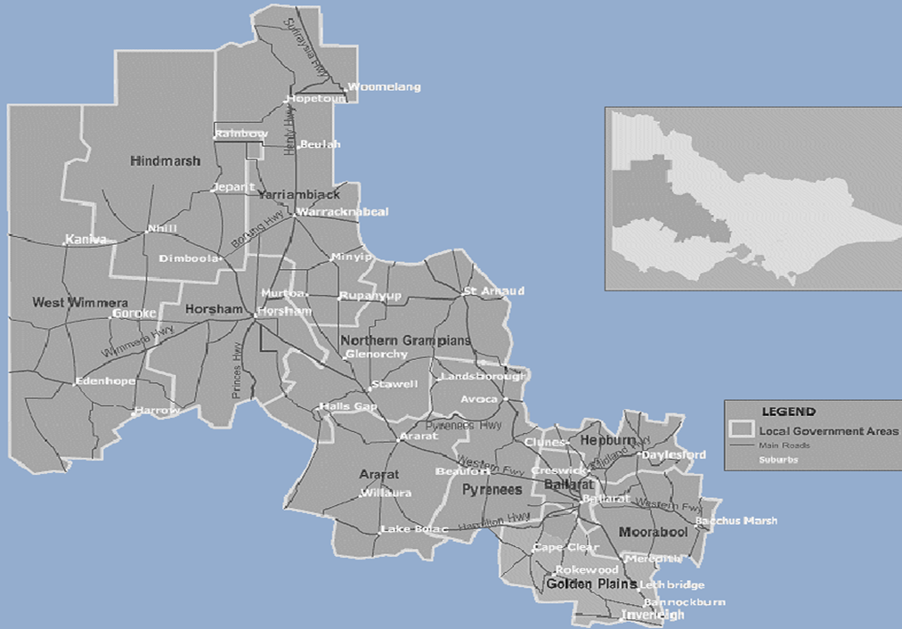

Figure 1: Map of Grampians Region

More than 224,000 people, or 4.4 per cent of the population of Victoria live in the Grampians Region. People aged 65 years and over represent 16.7 per cent of the catchment population. Aboriginal and Torres Strait Islander people comprise 0.9 per cent of the population in the catchment. According to the 2009 Census, there were 25,264 children aged from birth to six years living in the region[1].

The population of Moorabool Shire is projected to increase by 30% between 2010 and 2022, while the population of Hindmarsh is projected to decline by nearly 6%. Ballarat is expecting an increase of 23.7%, representing an additional 1932 children aged 0-6 years by 2026. Moorabool is expecting an increase of 17.7%, representing an additional 437 children aged 0-6 years by 2026[2].

Many families in the region live on remote farms and in small townships where they experience great difficulty accessing services of all types. Over the last decade frequent drought has been a cause of considerable stress for affected families and businesses. The region has a substantial proportion of families on low weekly incomes and the socio-economic disadvantage index is relatively high.

## Regional Workforce Context

The Grampians Health Region employ approximately 3,500 nurses, 410 registered medical practitioners, 49% of which are in general practice and 756 allied and oral health professionals in the region

The majority of this work takes place in the public health care system. The average age of a Registered Nurse is 47 years old and the average of a Midwife is 52 years old. The Region in total has six paediatric consultants who work both public and privately.

We have a Deakin / Melbourne University combined Medical School who host 120 medical students per year and partnerships with several other universities for rural medicine, allied health and VET sector early entry level workers. We also have two university providers of nursing undergraduate programs.

Ballarat Health Services (BHS) Base Hospital is not a paediatric hospital; rather it is a general hospital which serves the Grampians Region as the primary referral centre. BHS’s Paediatric and Adolescent Unit is the regions only facility able to admit children requiring specialist paediatric care.

With 14 inpatient beds and 6 day procedure beds, ours is not a large unit yet we see more than 200 admissions each month. Admission diagnosis spans the full paediatric spectrum as well as medical/surgical specialties. Children and young adults from neo-nates to 18 years of age are admitted to the unit. Seriously ill children requiring greater resources than our regional centre can offer are transferred to Melbourne’s Royal Children’s Hospital which is an hour and 15 minutes away.

With around 30% of admissions originating from beyond the greater Ballarat districts, the relevance of receiving appropriate and timely transfers from rural and remote sites is paramount. While the broad range of skills held by such rural based nurses is enviable, educational opportunities for them to develop their skills in paediatric focused triage and management of the seriously ill child is extremely limited.

By taking the experience of simulation based learning to rural and remote sites it becomes possible to for these clinical staff to develop better skills, process's and outcomes for their local children and families.

# 2.0 Project design

A literature review was conducted to establish existing mobile approaches to delivery of paediatric simulation based learning. Flinders University of South Australia had pioneered mobile simulation with the purchasing and refitting a van to become a pseudo ambulance. The premise was not to deliver learning in the van but use it to deliver manikins and equipment to provide education in regional and remote practice environments.

Queensland has also a series of Pocket Simulation Centres as part of their Clinical Skills Development Service[3].

Internationally, NHS Scotland had commissioned the construction of an articulated truck/semi-trailer. Simulation education is delivered on-board as the vehicle regularly tours Scotland’s Regional Hospital Trusts.

The reviewed approaches to the same goal are markedly different. The Scottish approach provides a self-contained, dedicated simlab on wheels, while the Flinders University approach relies on delivery of education within the participants own rural or remote practice environment. The first solution provides a more controlled learning environment but is very expensive to establish and operate. The “on-board” approach also places participants in an environment which may not reasonably emulate the actual environment in which they practice. The local environment approach ensures that the learning occurs in the participants own clinical setting and so better emulates the participants “real world” clinical setting. The cost of vehicle acquisition and refitting is also significantly less with this approach.

For the project to meet its objectives, practitioners throughout the Grampians Region require equal access to the services which SimVan could provide. The needs of larger centrally located institutions could not outweigh the needs of smaller more remote institutions. To assist in enabling this, online information and a booking system was developed whereby participants can view current and future SimVan bookings and request dates as are available. These requests can then be clustered into geographical areas and requests are then negotiated and confirmed.

In order to promote greater ownership and participation in the operation and delivery of the SimVan project, regional and remote clinical educators within the Grampians Region have engaged in workshops which introduce simulation based learning methodology, beliefs and goals so that they may be directly involved in the design and delivery of programs which are of most relevance to their staff. The “First Steps” program has been running over the past six months and has been widely supported throughout the region. Key staff have also completed the NHET-Sim program.

# 3.0 Vision

The vision of the Grampians Regional Mobile Integrated Simulation Unit is to lead in the design, mobile delivery and evaluation of regional simulation and clinical skills education for professionals, students of health care and members of the community

By offering a mobile integrated simulation unit to the Grampians Region, we are investing in the future of the regions health care professionals. All staff and students in the Grampians Region will now have routine and timely access to appropriate simulated clinical environments enhancing paediatric skills training, continuing professional development and assessment which will reduce potential risks to patients and increase confidence and competence.

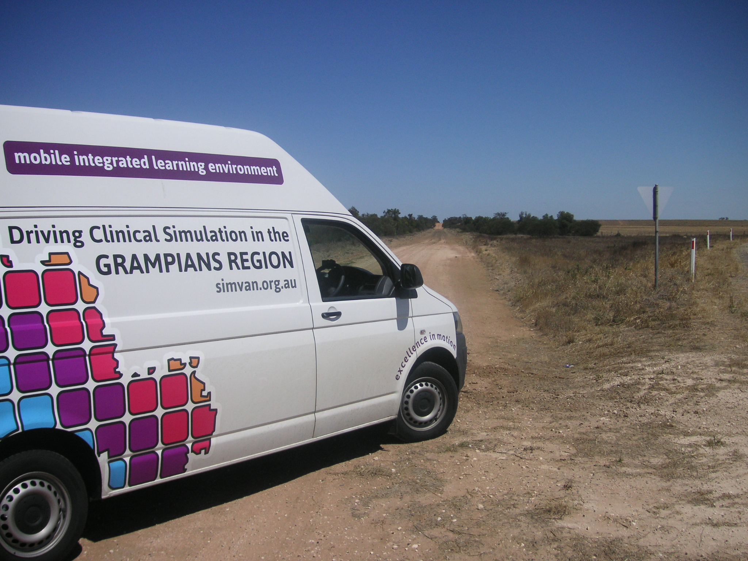

Figure 2: Grampians Region Mobile Simulation Unit

By creating this mobile environment, health care students and professionals at all levels of expertise can experience and safely practice skills and responses locally. Simulation is not only about gaining expertise in technical and procedural skills, it also focuses on the cognitive and psychological elements required for good clinical decision making and practice.

The mobile integrated simulation van is an interactive teaching and learning space that comes to you, it means that GPs don't have to close the practice for the day to come to training 4 hours away and ED physicians can experience close to reality paediatric events they don't see very often.

***“Innovation in delivery modality demands innovative use of technology”***

The above statement is not so much a quote but more a realization which occurred during the development of the SimVan project which resulted in available technology being used in a fresh and innovative way to solve a new challenge.

**4.0INNOVATION**

Delivery of simulation based learning in a mobile format requires the same key components as found in a traditional Sim Lab. The difference being that such components must be portable and adaptable to a range of clinical environments; this includes manikins, equipment, consumables and audio/visual capture capability. A mobile audio/visual system would ideally feature:

- Multi camera video capture capability.

- Editing capability.

- Rapid or instant playback capability.

- Lightweight and compact design.

- Wireless connectivity.

- Simple, reliable set up and operation.

A review of film production and security industry products revealed that there is currently little available which can meet all of these requirements. The majority of available equipment is designed for hardwiring to a specific environment, requires mains power supply and extensive cabling which reduces or precludes portability.

Adapting such film or security based equipment to a mobile application was considered, however proved very difficult to modify and could never fully meet the design brief. Achieving portable, multi camera, wireless operation was a common stumbling block which defeated many potential systems. The Scottish designed SMOTS (Scotia Medical Observation & Training System) Trolley offered a seemingly ideal solution however, an absence local representation or product support lessened its appeal.

Ultimately a clean sheet approach was adopted and local company, Cartesian Creative were commissioned to design and build a portable version of a traditional Sim Lab A/V capture system.

**4.1 “Control Room”**

The Control Room system comprises, Mac Mini, Wireless Router, iPad and 4 X Samsung Galaxy Smartphone’s with a variety of phone mounts. Hardware components are available “off the shelf” and as such are widely available and easily replaced or expanded. The system requires power and cabling of the Mac Mini and router only, phone/cameras and iPad are self-powered and communicate wirelessly.

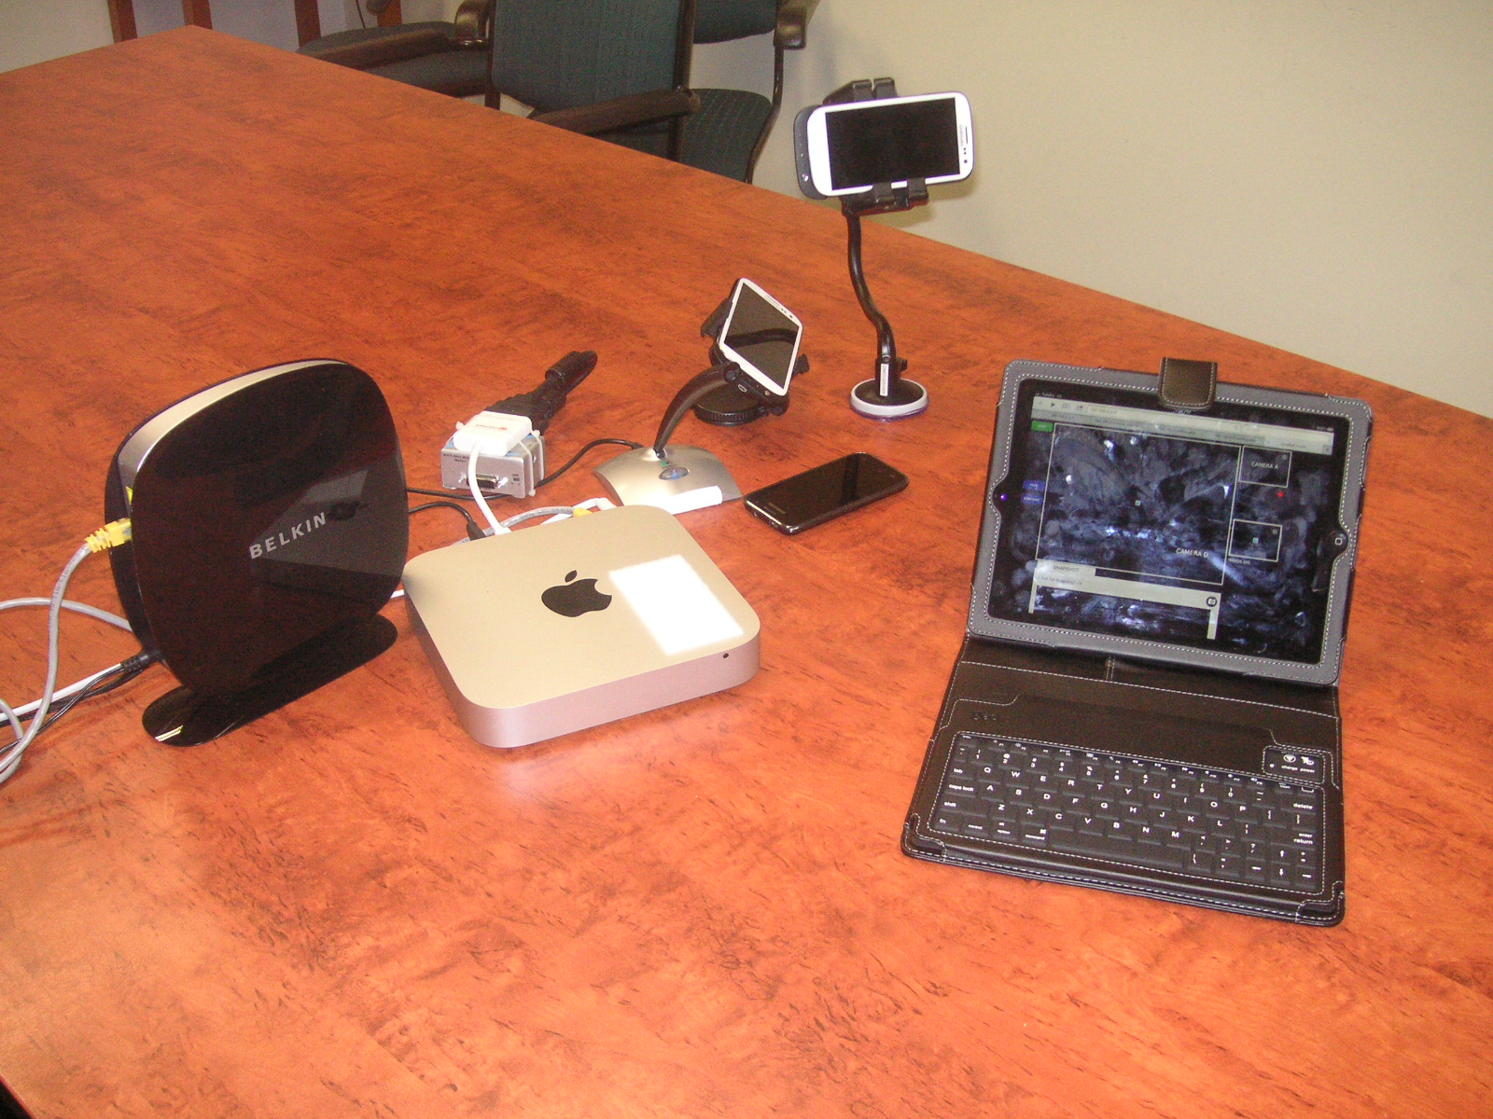

Figure 3: “Control Room” Equipment

The control room system can be stowed and easily transported within three computer satchels. It is compact, lightweight and easy to set up and operate. Due to its compact and portable nature, it is also unobtrusive and does not detract from the simulation experience by introducing unnecessary and intimidating equipment to the scenario.

‘Control Room” operating software has been specifically written to accommodate the design brief. Hardware components communicate via a secured Wi-Fi network allowing for multi-camera video/audio capture, playback, book marking of events, note taking and real time editing. Playback can be viewed directly via the iPad or linked to any HDMI equipped television or screen.

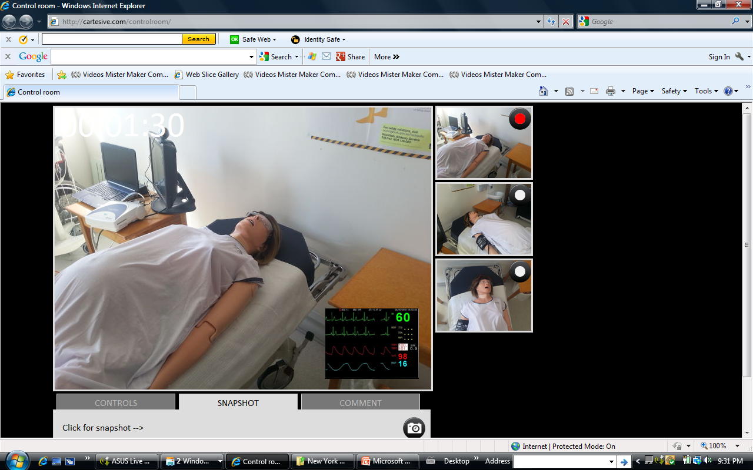

Figure 4: Screenshot of "Control Room" in use

**4.2 Limitations of project design**

The physical size of the Grampians Region (48000sq km) makes it difficult to adequately service the demand for this type of education given the current project resources. Although still in its infancy, SimVan bookings are already exceeding availability.

As expected, substantial amounts of educator’s time is being spent travelling to and from remote sites rather than delivering education, thus limiting efficient use of human resources.

The “Control Room” A/V system remains in prototype form and requires further development before a production ready version becomes available.

**5.0 Conclusions**

The implementation of the SimVan project has shown that it is possible to successfully deliver low, medium and high fidelity simulation in a mobile environment.

The launch of SimVan has made participation in simulation based learning available to clinicians who otherwise would not have access to such learning.

SimVan has shown that it is possible to package and deliver a complete simulation based learning experience in a mobile/portable manner with the added advantage of tailoring scenarios to best suit participants local environment and resources.

Already, the uptake of SimVan within the Grampians Region confirms the need for expansion of this type of educational service.

# REFERENCES

Clinical Skills Development Service CSDS. Accessed May

17, 2013. <http://www.sdc.qld.edu.au/>

Department of Health. Accessed March 12, 2013.

<http://www.health.vic.gov.au/>

Department of Human Services. Accessed March 12, 2013.

<http://www.humanservices.gov.au/>

Kneebone, R., Arora, S., King, D., Bello, F., Sevdalis, N.,

Kassab, E., Aggarwal, R., Darzi, A., Nestel, D., 2010,

Distrubuted simulation- accessible immersive training,

*Medical Teacher*, Vol. 32, No. 1: Pages 65-70

The Mobile integrated Learning Environment is made available through funding by Health Workforce Australia and the Department of Health, Victoria.



1. Department of Health Website – accessed 12/3/13
2. Department of Human Service Website – Accessed 12/3/13
3. Clinical Skills Development Service website – accessed 17/5/13