Survey Monkey Evaluation Project 1 – Facilitator Training Program
Question 1
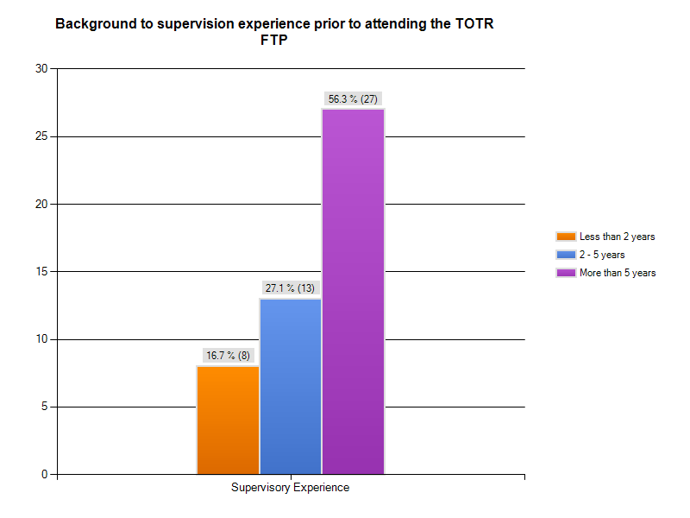
Question 2
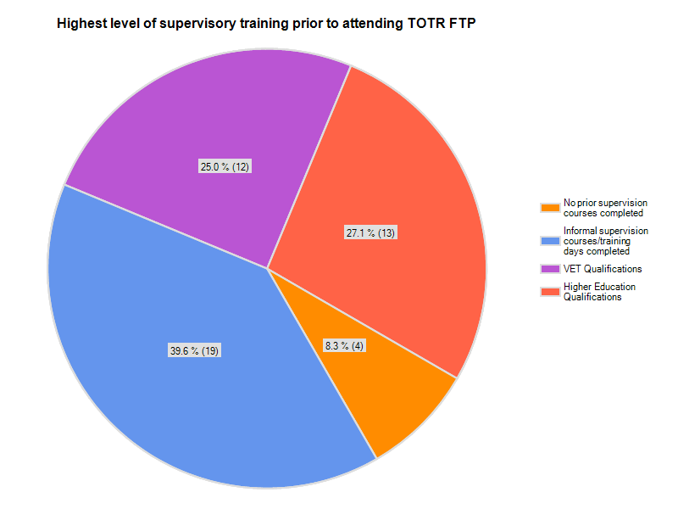
Question 3
- RN1, grad cert nursing
- Bachelor of Applied Science - Education major, Cert 3 Education & Training
- Certificate IV TAE, x 19
- Local Preceptor training and facilitation courses
- Australian Clinical Educator Preparation Program
- Masters of Education
- Master of Nursing - Nursing education subject, Organisation based preceptorship course
- Advanced Certificate in Clinical Education (ACE) x 2
- Graduate Diploma in Nursing (Education)
- Graduate Diploma CBE, Life keys Facilitator Training Program
- Clinical supervision courses run at Eastern Health - novice to expert
- Preceptorship/frontline management, advanced diploma in business/ certificate IV -education
- Grad Cert in Clinical Nurse Education
- Preceptorship courses within Eastern Health, Masters of Adult Professional Education and Training
Question 4
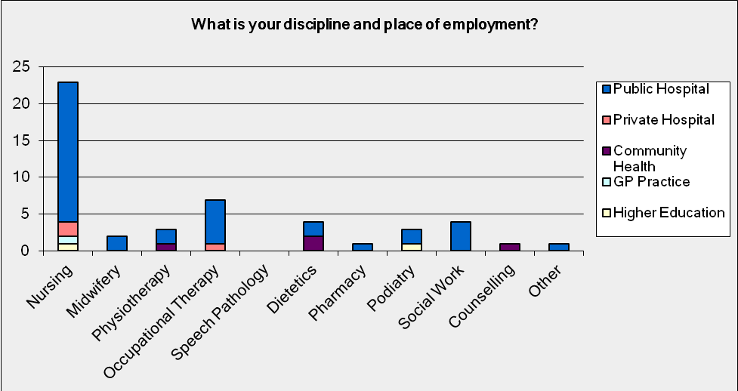
Question 5
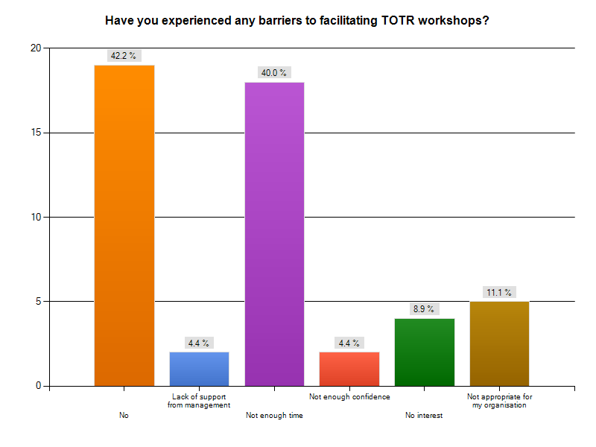
- Time to arrange staff is challenging
- Limited interest rather than no interest, reduced time rather than no time
- Content, IT issues
- Poor staffing levels in clinical areas resulting in staff cancelling at last minute or not able to commit until last minute
- Not had opportunity to
- Limited interest by potential participants
Question 6
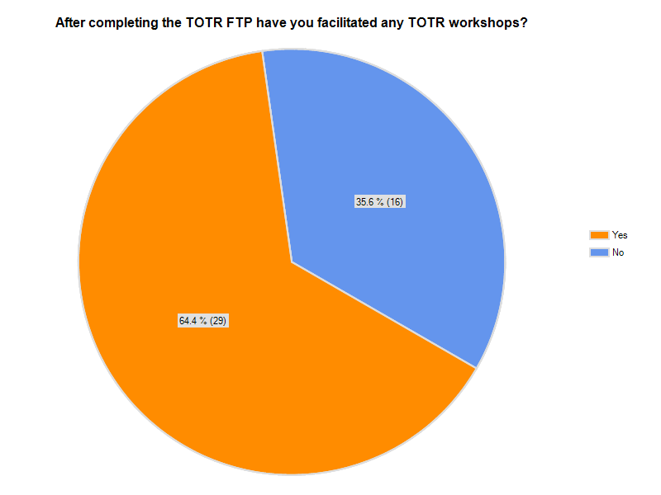
Question 7
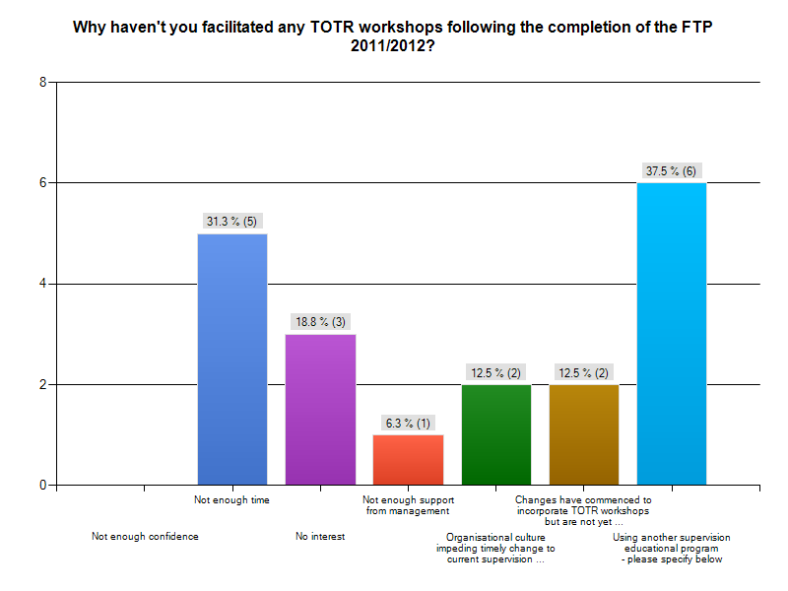
Other
- TOTR is facilitated in our campus and designated trainers from the course have been allocated this space. Saying that the principal of TOTR is something I continuously offer in my other programs that have a simulation content to empower the participants and create an ethos of TOTR to all that take a way a new educational skill or knowledge to empart to their peers. Also utilise the time I have as an educator in a clinical setting to perform impromptu TOTR sessions as the need arises from the clinical workplace.
- Currently using a program developed in house
- I am schedule to complete my first workshop in the next 2 months. Prior to this the opportunity others were prioritised to gain confidence with facilitating the workshop, which suited myself and my time requirements.
- Run a Preceptorship program already for mental health
- Not been asked or required to
- TOR was not suited to TOR in the nursing workplace in its original form and we were informed that it was copyrighted and we could not adapt it to suit our profession and organisation.
- Current role doesn't allow for this at present due to being totally committed to supporting and facilitating a post graduate program
Question 8
What strategies would need to be in place for you to run a TOTR workshop?
- Enough staff to be able to cover my time off the floor to provide adequate time for me to prep and run them.
- TOTR is already happening as a workshop in our organisation.
- Permission to access this information and resources at a low cost to roll out across all sites
- All sessions available on website (they weren't all available when I completed the workshop and I was unable to find the correct contact details to obtain them from TOTR)
- Well it is happening-it's just taken some time to rotate through facilitators to get to my turn to facilitate.
- Working again in a Dialysis Unit with Students and new staff, then TOTR is great and possible, but I am working in an office job.
- Training was confusing
- Not interested
- Allocated time and support.
- Nil happy to run one
- time to prepare/ time allocated to present
- Its been a while now since completing the course, I might require a refresher.
- More time
- Freedom to adapt the program to our context. I understand that this has occurred in Eastern Health - not sure -I do not participate at this stage
- Would need a different role in the education team
Question 9
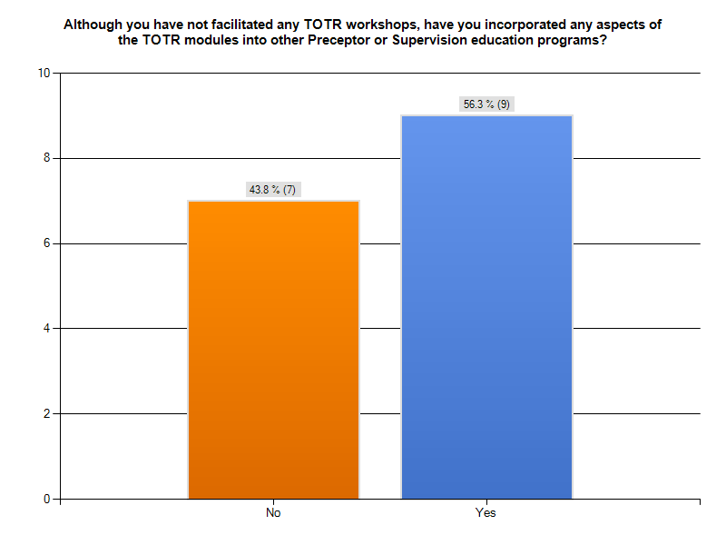
Question 10
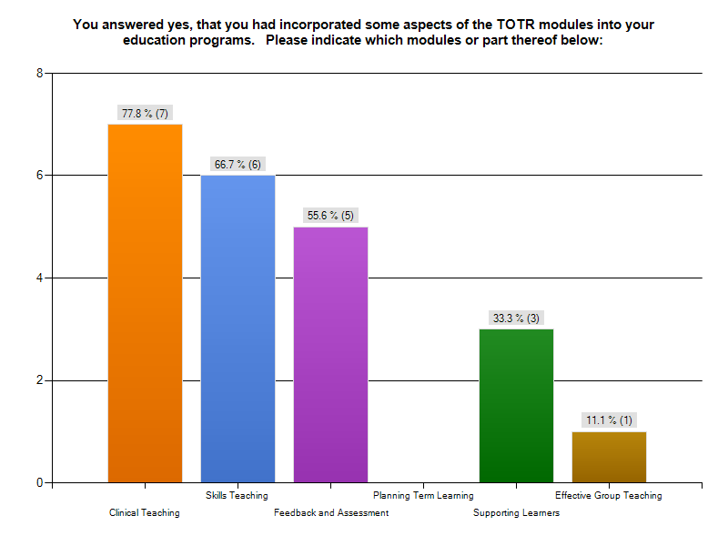
Question 11
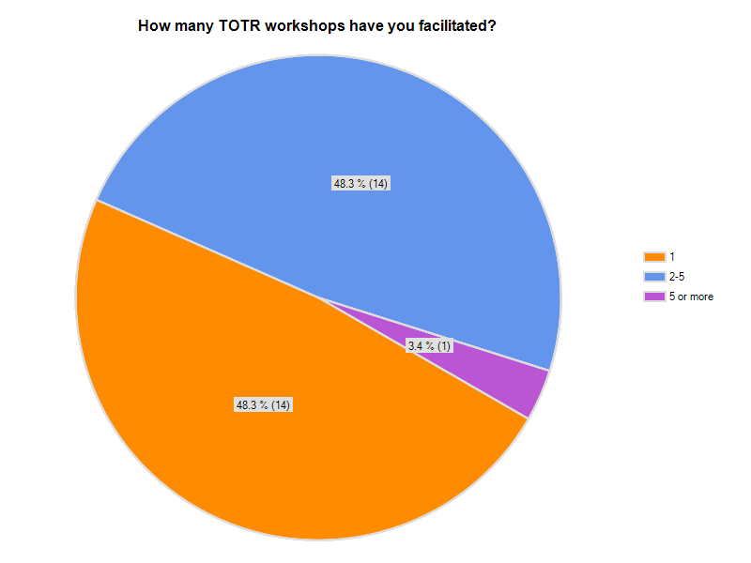
Question 12
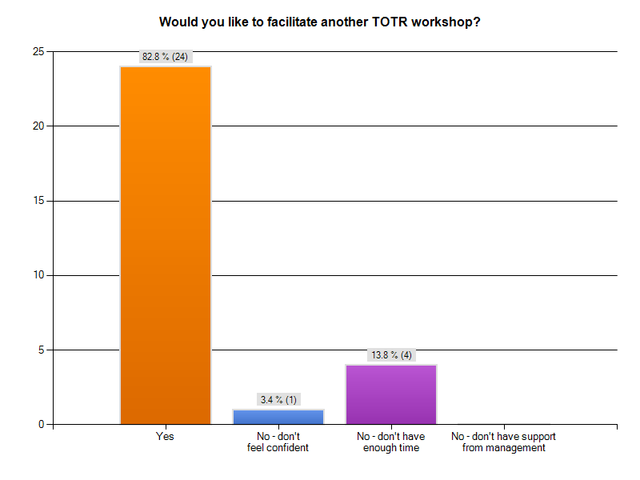
Question 13
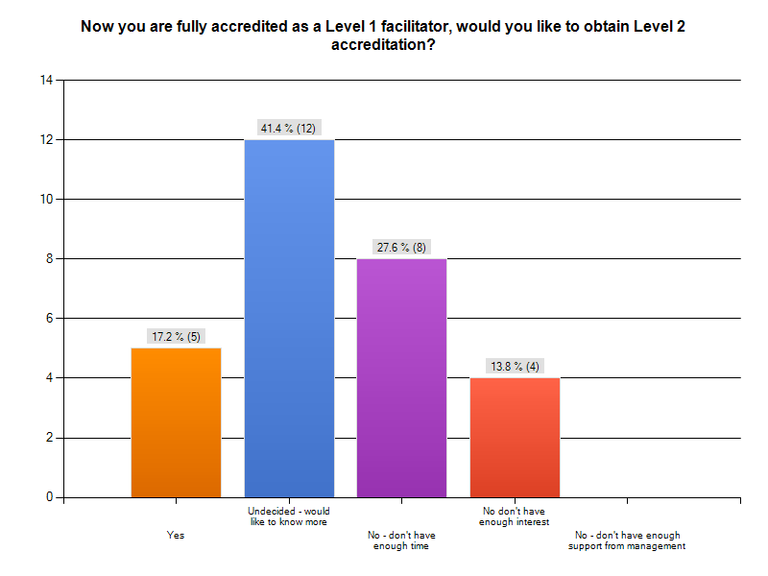
Question 14
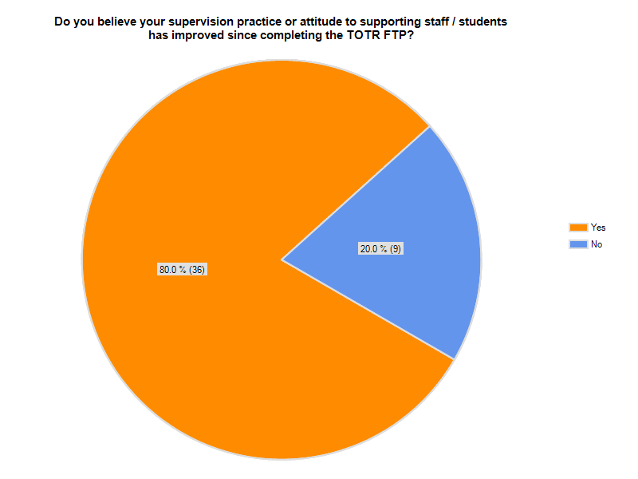
Question 15
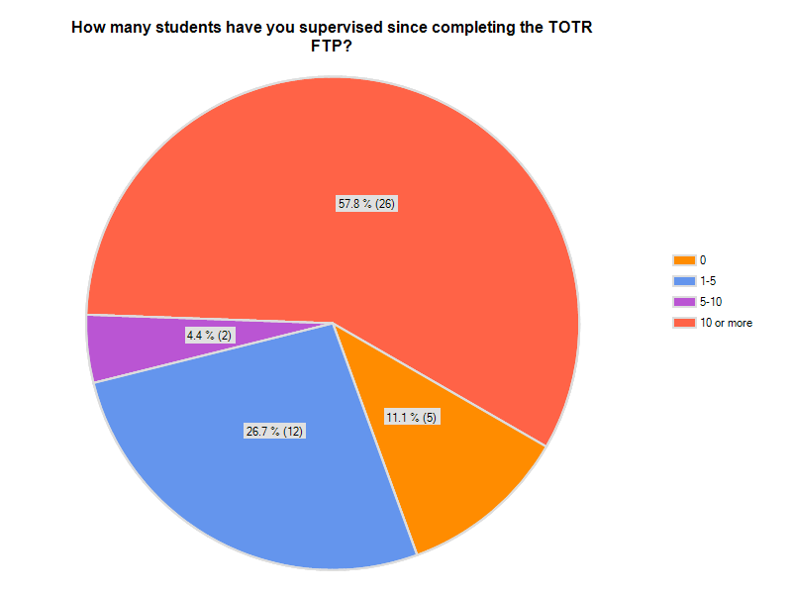
Question 16
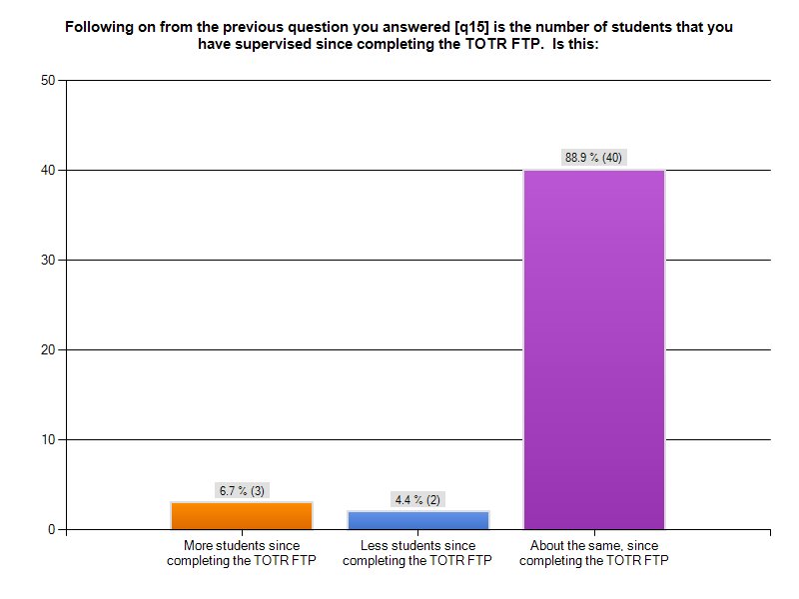
Question 17
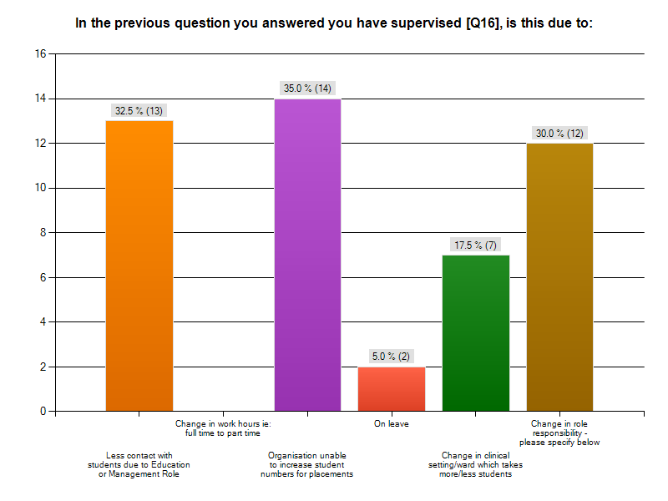
Question 17 continues, please specify;
- Changed role from educator to clinician
- More in-charge roles making less time to preceptor
- Matrix changed. Portfolios changed. Now have responsibility for more students and nurses for their education
- We haven’t been given more students by university
- I work 2/7 in a community program that probably doesn’t offer enough direct contact for a student. The other role is a generic role and there is several contraindications to having students in this role. However, I often assist my colleagues with their student supervision by taking students for the day / observation with aspects of my practice. I also supervise 3 Social Workers and student issues are common in supervision.
- There is only one intake a year of students and so there only has been one opportunity
- I was supervising more staff - rather than students due to a change in my role, however, this has changed again and I will be taking a SW student this year.
- We are at maximum numbers
- Hasn't been the opportunity to supervise a student in my part time position
- Re structure with the organisation
- Team lead role - less ability to take students
- Resigned from education job
- No I continued doing the same as usual - supporting undergraduate students and Graduates and staff in the workplace
- Already supervising 12 students on a regular basis as well as 2 other UG students
Question 18
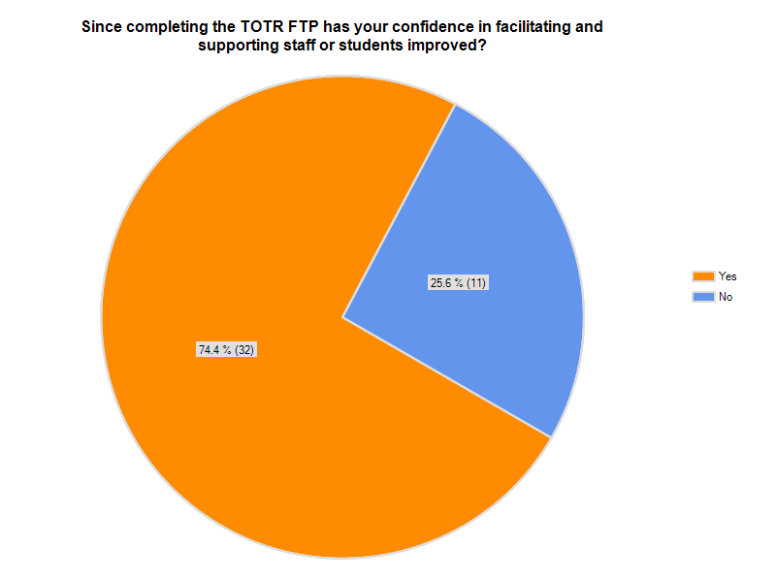

19. You answered [Q18] why do you believe your confidence has not improved?
- Don’t feel there is any information in the course that I was not using previously in education
- Due to previous experience confidence is high
- I was already confident in facilitating students
- I had always confidence with students but I changed job and have no contact with students anymore.
- Broadened my skills but did not deepen them.
- Training was confusing and I have completed other courses in clinical supervision which were more appropriate for my workplace
- My confidence in presenting has improved
- Already felt confident.
- I didn't feel like the course taught me anything particularly new. It felt like common sense, perhaps because OT is very much about teaching and engaging with others anyway.
- I was confident anyway as I have been doing this for many years and have learnt much during my studies, and experience in teaching in the workplace
- Was already confident in the role but have used some of the strategies from the workshops in my current role
Question 20
What if anything have, or will you change in your supervision of students or supporting staff since completing the TOTR FTP?
- Utilise the simple techniques used consistently with all staff students
- Not anything
- Nothing much
- Encourage staff to be more patient of learners and to put themselves in the learner’s shoes.
- Planning micro teaching sessions for students
- Actively teach TOTR in the word setting as a process that is to be embraced , rather than waiting for formal education sessions to be established. Empowering precetors to recognise this as a tool to assist them in ongoing teaching and assessment of their preceptees. To continue to talk the model as an effective 5 minute process in the busyness of the acute ward settings to bring skills and knowledge to a set of staff without causing undue effect on the patient care .
- N/A
- Asking students and staff to give their own feedback first then offering both positive and negative feedback
- Feedback, attempt education in limited time periods
- Improved strategies for providing feedback.
- Recognise the small windows of time in which to teach a skill or activity
- Being able to assist supervisors prepare better for their student. In my own supervision using the framework of positive critique
- Using a framework to better structure teaching sessions - however opportunistic they may be.
- Nothing
- Adapting positive critique and cycle of learning
- Method of giving feedback
- Increasing the skills of the staff that I work with who supervise learners with my support. Encouraging these staff to attend TOTR.
- Staff debrief and discussion/workshopping challenges and experiences with supervision has proven to be very valuable - increase these opportunities
- Nil
- I will go back and draw from the experience but I really like my office job now
- It has been useful in supporting staff who supervise others and students
- See previous answer
- Perhaps an increased awareness in now to structure learning
- Giving the student the opportunity to positive critiques their performance.
- Nothing. But the way some of the staff under me supervise and provide feedback may have changed.
- The way information is delivered and information is taught
- The way I use learning opportunities and test students’ knowledge base
- Nothing
- More around teaching staff about how it doesn't take a lot of time to teach someone something
- The way I teach step one I never did and now I incorporate this into my teaching.
- Trying to fit a little more into small time frames, when otherwise you thought you didn’t have time
- Incorporating more debriefing time. Allowing more time for students to express themselves and their experience
- The methods I use to teach student - e.g. incorporating strategies learnt on the course.
- Ensuring feedback is given in a useful and constructive way to enable improvement and an increase in confidence.
- My approach to teaching, in particular tasks.
- I'm not sure.
- feedback delivery
- I have learnt specific ways to provide effective feedback to students in real time rather than waiting for formal supervision
- Don't teach too many things at once, have key messages
- Feedback and reflective tips
- Nothing
- Utilising the short snapshot sessions
- Method of teaching
Question 21
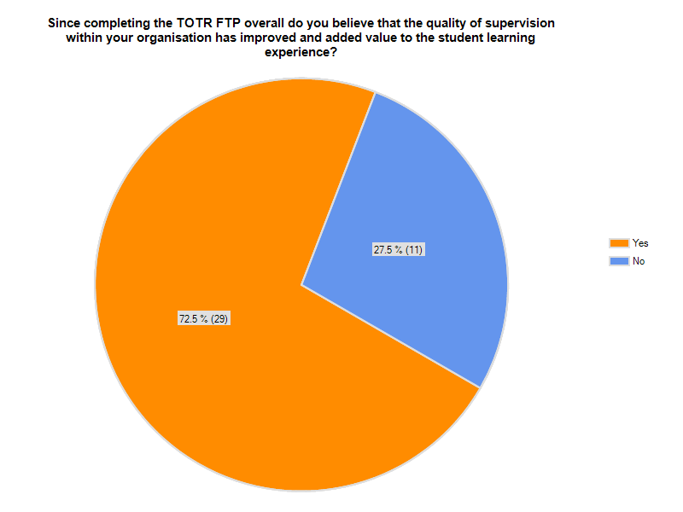
Other - feel free to make some general comments
- Hopefully helped nurses on the ward preceptoring
- Time & financial constraints
- We are definitely in the early stage of getting this program understood and excepted by the staff as a way to help them improve student learning without putting more work onto the preceptor. I believe it will take more time before we will be able to get some valuable feedback to support this question
- We have a good level of supervision ability already but hopefully TOTR has added to this
- Many of our supervisors are very experienced and as yet have not been able to expose more of our junior or newer staff to these supervision roles to TOTR
- It's a slow transition and another change but I think its progress and a welcomed change.
- I feel giving feedback will improve my using the positive critique format
- Not enough staff have completed the training yet and staff are no longer able to access other training programs. Trying to get more staff to complete the training. But the feedback from the staff has been very positive so once we have more staff trained it should improve. TOTR is good for all staff involved in supervision but those who have a more significant role in supervision would benefit from access to other previously used training programs.
- A lot of people who did other sessions thought it was a waste of time
- Unsure if programs have been run in institution. Plus difficult to answer as so many changes have been implemented in institution since, causing issues with student learning experience.
- I am not aware of any other staff in my department completing the training.
- If it has improved it is as result of the current TOR course which is run and has been adapted for use in our context, so it is not the original TOR program

