Survey monkey evaluation project 2 – Participants of workshops
Question 1
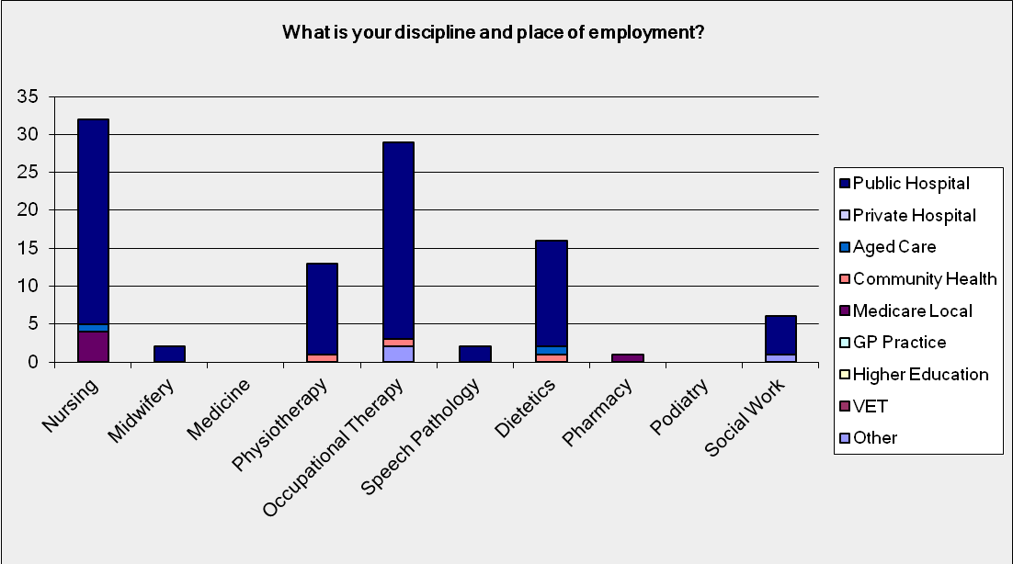
Question 2
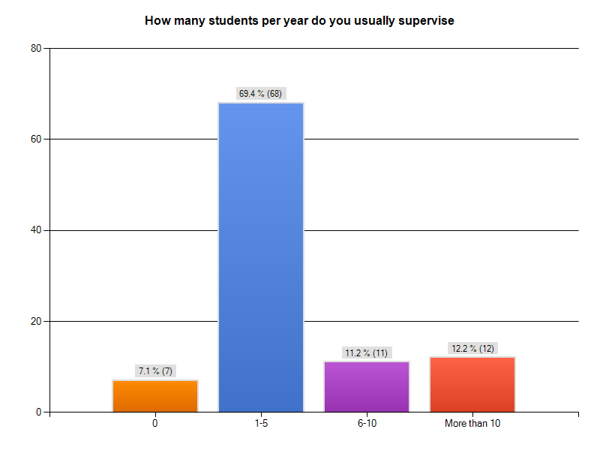
Question 3
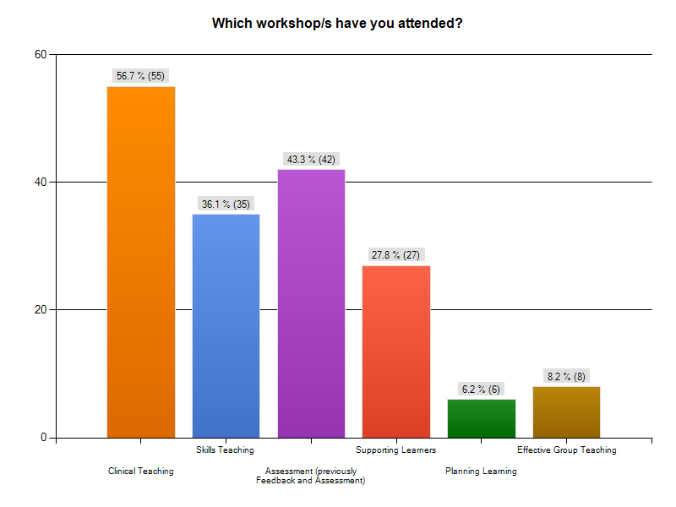
Question 4
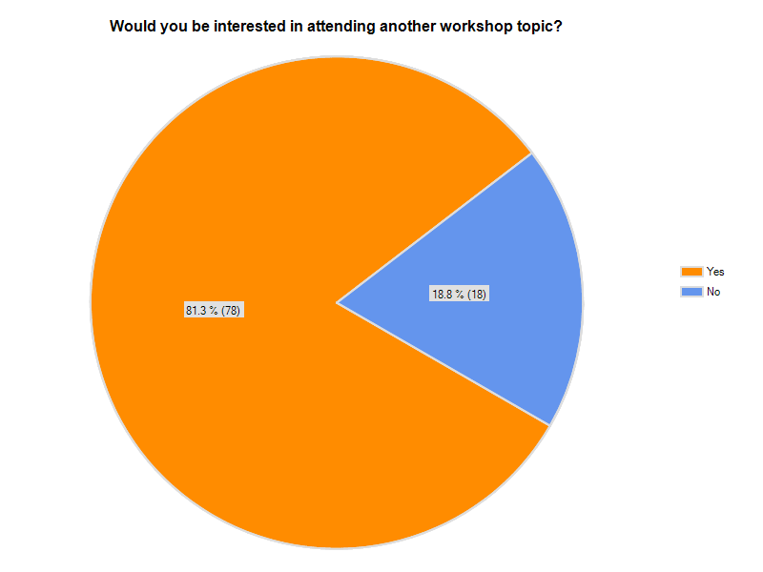
Question 5
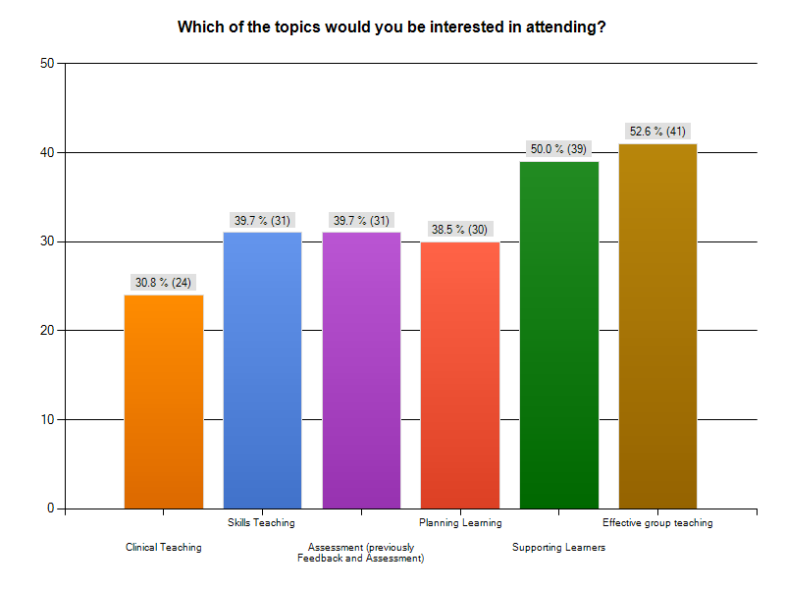
Question 6
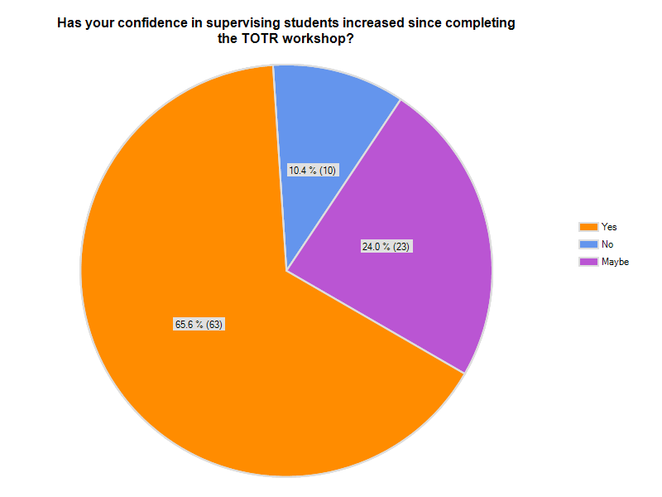
- Importance of clear, specific feedback x2
- the skills in guiding the students
- Ways to approach a student who is struggling in clinical placement
- Provided some good examples & techniques which I have adopted when supervising students.
Help to reinforce my areas of strengths re: student supervision.
- TOTR workshop provided the guidelines to enhance my teaching skills. The 5 minutes presentation has assisted me in developing confidence to supervising nursing students while I was on the run on ward.
- I liked the questions " what did you do well/not well etc" Have found that technique useful
- It is still hard to educate /supervise whilst you have a very heavy work load as most do now in this economic work environment. Reduce the load and the supervision can be improved
- After attending TOTR workshop it has highlighted that I am often engaged in teaching on the run with students, clients & other health professions. I now make these short opportunities as effective as possible which has resulted in increased awareness, more feedback & more positive actions taken by recipients and I too provide more constructive & non personal feedback
- Felt I emerged with greater skill and flexibility in giving feedback to students, both positive and negative.
- I am more focussed on delivering short / clear education / messages, & reflecting back to ensure learner knowledge / understanding
- It was reinforcement of what I had already learnt through sessions run by the universities for clinical supervisors
- Provided me with tools and framework for which to shape my supervision
- It has helped me by involving the student in setting up their own goals
- adult learning styles, reflective teaching, feedback skills
- How to deal with under-performing or difficult students
- It has reminded me that short bursts of information can be a great effective way to teach skills.
- I have more of the language for report writing. Also more knowledge about the requirement on how to fail a student well
- Reinforced strategies used to provide effective feedback
- The workshop has made me more aware of how I question a student, the way in which i approach that questioning & how those students may perceive me. It has also reinforced the need for accurate assessments.
- Confidence in talking
- Highlighted how information can be presented and passed on in short spaces of time, rather than structured timely tutorials.
- It validated previous experience and education related to teaching students. It also gave insight into working with this current generation of undergraduates. The framework was useful.
- As someone who has been away from the workforce for some years (on mat leave), the course was a great way to reintroduce me to students and supervision, specifically reminding of what it is like to be a student, and how they 'learn'.
- An update on teaching methods and positive reinforcement.
- Has built upon my preceptorship skills as I have already been preceptoring students and grad nurses for more than 5 years
- But that is because I don't directly supervise students. If I was I would say that my confidence has improved.
- Just knowing educators are available to assist preceptor if difficulties arise.
- How to construct feedback for students, best way of providing feedback to students
- Greater awareness around how to make better use of impromptu opportunities for teaching
- Case studies and interactions validated difficulties at times to assess and provide feedback. Increased my awareness for students learning needs and styles
- Importance of asking questions to delve deeper and to provide a more helpful supervision for clinician
- I have had limited opportunity since the workshop to supervise students.
- Validated some processes we already utilised, and introduced some new strategies. Mostly however it increased our thinking about assessment and feedback.
- Not sure that it has changed the way I teach but has given me more confidence in student supervision.
- I have developed improved skills in listening, assessment, group teaching skills
- I was already confident in supervising students before this one day workshop
- I don't supervise any students, so this question is not applicable for me
- I have learnt strategies in assisting students and how to more accurately assess them.
- Increased knowledge of adult learning principles.
- I have supervised many students over 20 years and completed much training in this area as well as general supervision. Furthermore I have run parenting courses for groups of up to 20pp.
There really wasn't anything about this training that was new or challenging. I did it because it was compulsory.
- Spending time developing skills re: supervision and being able to discuss different strategies with colleagues and trainers has increased my confidence.

Question 7
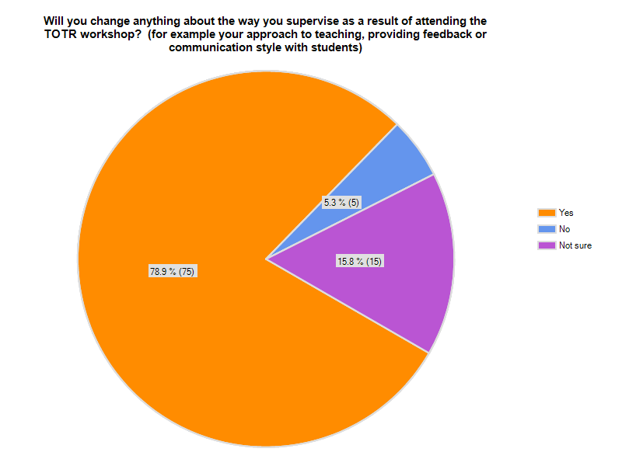
Question 8
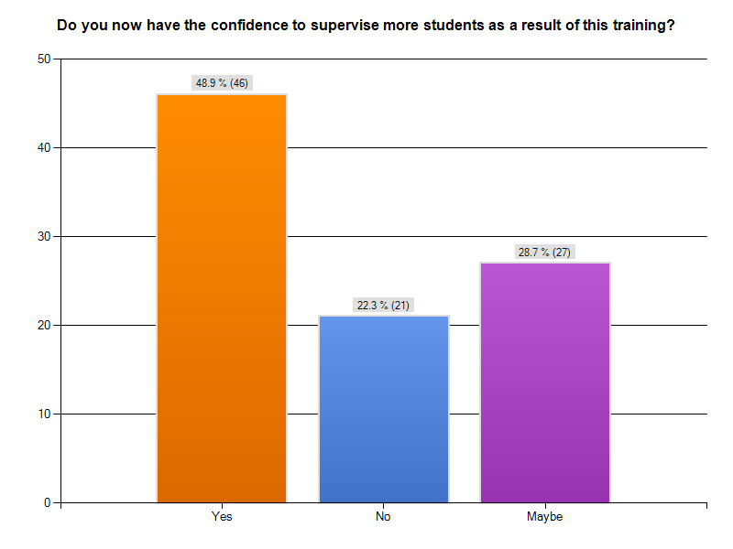
Explain your answer regarding level of confidence to supervise more students.
- Haven’t got any student to supervise before, just got the theory. If have the practical together will be better
- have been doing this for years and already supervise two students at a time over 30 weeks a year
- No time
- I am teaching and learning to teach at the same time. Teaching skills can only be improved in experience.
- easier to communicate clearly with them
- Depends on management
- However staff resourcing an issue
- Reinforcement of previous knowledge/skills
- Our current staffing and the clinical workload would not enable us to increase our student numbers
- Trying to supervise more than one student at a time whilst trying to do your work load and care for your patients is difficult
- More practise and positive feedback from other course attendees gave me more confidence
- I have always felt confident in supervising students but this course has reaffirmed and enhanced my abilities to supervise & evaluate learners. It has provided me with more strategies to help identify the individual needs of students and how i can more appropriately assist in their learning
- I do not have the capacity to supervise more students from a time perspective rather than a confidence one
- Always felt confident! I am limited by nature of the work I do
- As mentioned previously, having been out of the work force for a few years made me "forget" what it was like to be a student. As a part time employee, time is very much of the essence: the course reminded me of what it was like to be a student; the different learning styles people have, and thus has given me more confidence to supervise future students
- I don't directly supervise students as part of my work role
- Better understanding of how we learn best
- Validated expectations for students
- Don't think it prepared us to supervise more students, just to supervise the ones we have more effectively.
- I am a very experienced student supervisor and although there's always something new to learn I really didn't gain a lot from the workshop from memory - it was a long time ago
- My confidence has improved mainly reinforcing my current teaching methods
- I am already confident and already supervise many students from many disciplines
- N/A
- Increased knowledge and confidence with student supervision.
- I never had a problem with confidence before. The training was compulsory
- Confidence the same and is fine
- I am recent to supervision so I am happy with one student a year however more training may increase my confidence
Question 9
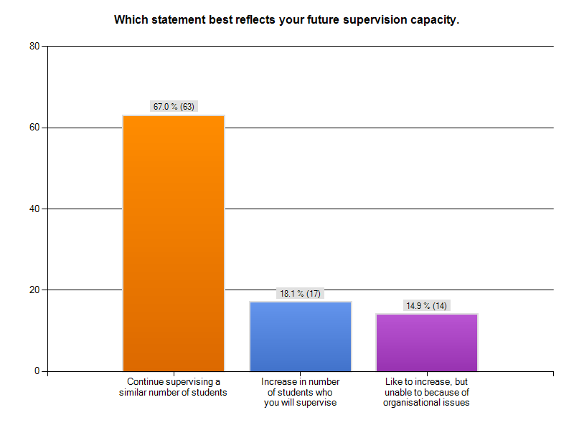
Other:
- Would like to have experiences in supervision and I think I'm confident enough for my supervision capacity once in practical
- I have moved into a management position so am not likely to supervise as much as I have previously
- Sometimes depends on the level of the students and how busy of the ward. If I take too many students at the very busy environment, it will increase my work load. Some students take more time to teach and supervise them
- The organization we work for has indicated that we will be expected to increase the number of students to be supervised & evaluated
- Hope to use facilitator skills to encourage others to increase supervision capacity
- Not currently in a supervisor position
- None of the above
Question 10
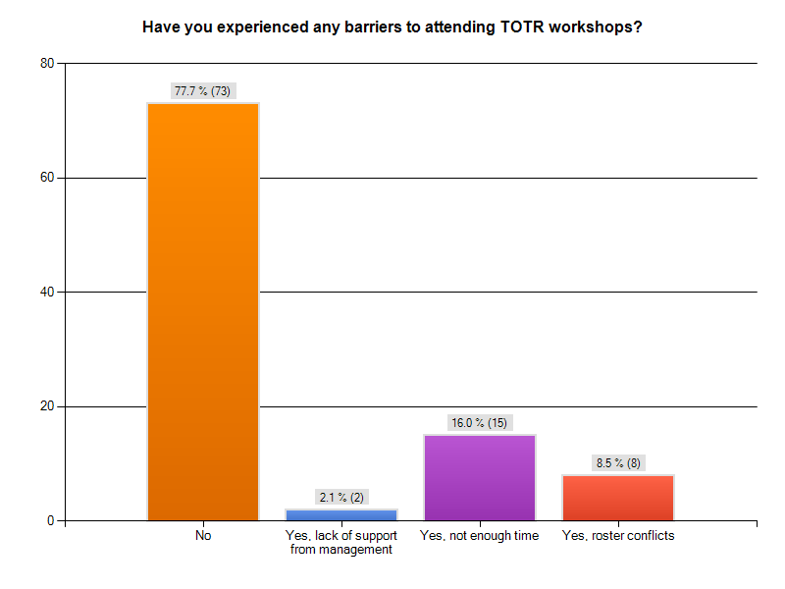
- My management was very supportive of doing this course
- Not been given the opportunity to attend additional workshops in this area of expertise
- The number of places were limited
- Attending the workshops without being paid
- It has been well supported by my seniors and I have been encouraged to attend
- The availability of TOTR workshops on offer
- HAD to attend, wouldn't have otherwise
Question 11
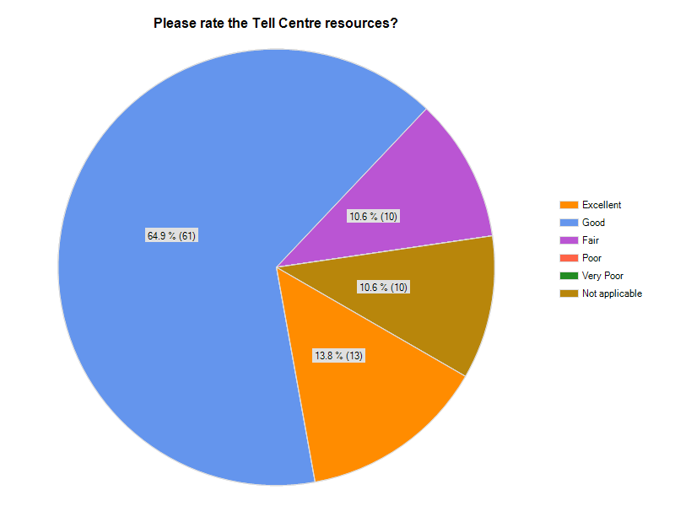
Question 12


