Fixed term funding case study
Simulated Learning Environment Program

Moog Simodont dental simulators for training dental students
Background
The Australian Research Centre for Population Oral Health has reported that there is a shortage of oral health professionals (dentists and oral health therapists) in Victoria, in particular in regional and rural Victoria. In an approach to address this workforce shortage the Melbourne Dental School (MDS), the University of Melbourne, has substantially expanded its student intake into its new four-year, graduate-entry Doctor of Dental Surgery (DDS) and also its Bachelor of Oral Health (BOH) programs. The new DDS course is replacing the heritage degree the Bachelor of Dental Science (BDSc) and these degrees produce graduates who can register as dentists and oral health therapists. The majority of the graduates practice in Victoria. The number of domestic students in the DDS has been increased from 35 per year in the old BDSc, to 70 per year building to a total of 90 students per year. The number of domestic students in the BOH has been increased from 20 to 30 per year. This will produce a total student body of 360 in the DDS and 90 in the BOH. This large increase in student numbers for the MDS presents a significant challenge in terms of clinical training by the clinical partners, Dental Health Services Victoria, Goulburn Valley Health and Latrobe Community Health. The MDS has expanded its student clinical placement program by working with regional and rural public dental clinics to be able to provide the clinical training required for the increased student number. Simulation training has been seen as useful addition to the training of oral health professionals and assists in the meeting the challenges of delivering clinical training to increased student numbers.
Problems/drivers
Dental students perform invasive procedures on patients and must first reach adequate competency by preclinical simulated practice. Traditional dental student preclinical training has required students to practice clinical procedures such as drilling teeth for restorations and crowns on plastic teeth in a simulated mannequin head to gain the necessary manual dexterity skills, hand-eye coordination and to develop a theoretical and practical understanding of these clinical procedures. This is usually done in the early years of the dental course, prior to the students undertaking these irreversible procedures on patients in the later years of the course. Plastic teeth present challenges, in that they do not accurately represent the anatomy, pathology and tactile sense of a real tooth, they are expensive and single use only, and often when a student brings a prepared cavity preparation to a demonstrator for assessment and feedback, it is already too late to see where and how errors have occurred. Haptics is the science of creating a realistic sense of touch in a virtual environment.
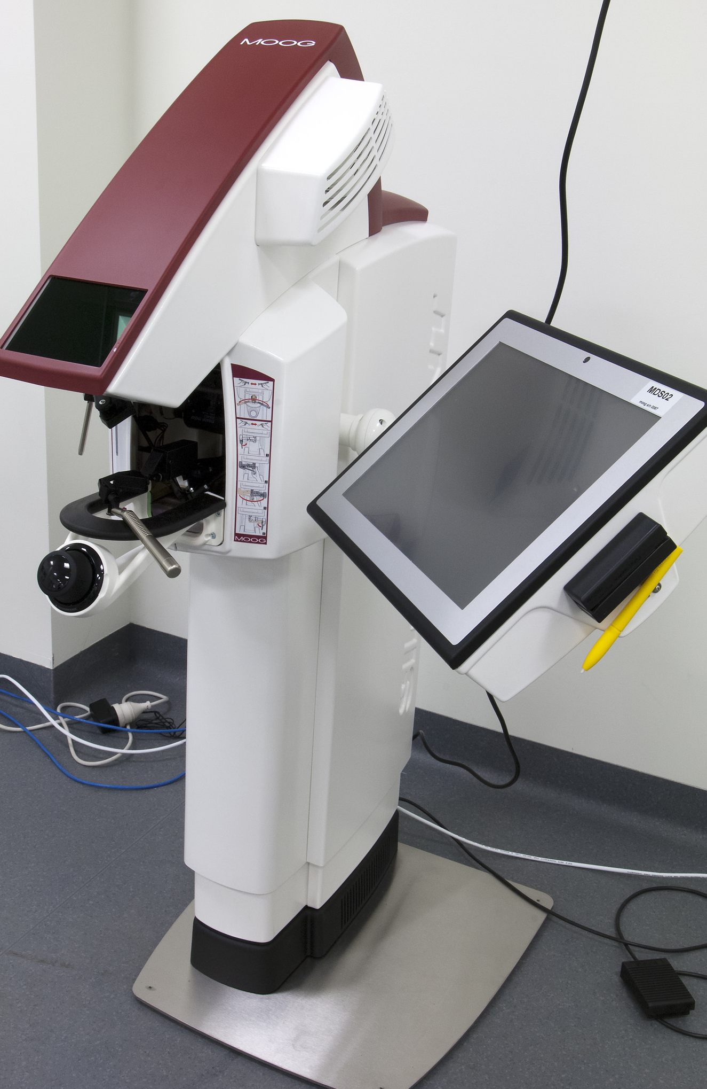
Figure 1: Moog Simodont Dental Trainer

The Moog Simodont Dental Trainer (Figure 1), developed in partnership with Moog and the Academic Centre for Dentistry in Amsterdam (ACTA), combines realistic dental procedures in a virtual environment that feels realistic through high fidelity force feedback with software that supports the enhanced curriculum design in the new DDS. Using these Moog Simodonts, dental students will be able to develop their psychometric skills and at the same time incorporate pathological dental conditions within their simulation training. The system teaches dental students how to drill in a realistic and virtual manner, mimicking the dental burr used by dentists for tasks such as removal of tooth decay, filling cavities or repairing fractured teeth for example. Preclinical training can be further enhanced through the introduction of virtual patients and sequential use of more complex dental procedures including fixed prosthodontics, endodontics, periodontics, implantology and tooth extractions. The experience in other countries with using the Moog simulators results in students being able to transfer their skills learnt in a virtual setting to reality (Bakker et al., 2010).
Arriving at a solution
The Moog Simodont allows students and teachers to review (in video format) the procedures performed, including the ability to pause and rewind, to provide high level feedback on a clinical procedure. Since students will not be irreversibly cutting plastic teeth, they are able to continually practice procedures without the additional cost incurred by requiring a new plastic tooth. The Moog Simodont offers a number of other advantages over traditional (plastic teeth) simulation. The Simodont platform allows for scanning using micro-CT of real teeth with real pathology, so that students are exposed to a broad range of realistic clinical scenarios rather than generic standardised pathology in plastic teeth. This will bridge the gap between the plastic tooth simulation environment and the real clinical environment, and better prepare the students for the diversity of clinical practice. Not only does the Moog Simodont allow for simulation in clinical dental procedures, but the software interface allows for the development of clinical cases for students to work through, in order to proceed to practicing clinical procedures. Therefore, important clinical skills such as examination, history taking and treatment planning can also be simulated and better prepare students for clinical practice.
Implementation process
Simodonts have been predominantly used for first and second-year DDS and BOH students, and also to support specialty training for Doctor of Clinical Dentistry and Postgraduate Diploma in Clinical Dentistry students. The Simodonts were ready to be utilised early this year. The Simodonts were introduced to the DDS first-year students at the start of first semester. The students used the Simodonts to learn manual dexterity skills, getting a sense of depth and tactile sensation. Using simulated 3D virtual handpieces and dental burs, the students learnt to drill in a realistic manner. As a result, we were able to eliminate the manual dexterity component in the traditional preclinical setting, reducing cost and channelling resources to other areas. The feedback mechanism of the Simodonts provided feedback at every stage of the task, as students were able to view (using the 3D video playback) where and how they went wrong and then, they were able to repeat the exercise and correct their mistakes. This is not possible with plastic teeth. One of the objectives of the Simodonts was to bridge the gap between the traditional preclinical setting and treating patients in the clinics. The DDS second-year students used the Simodonts to bridge this gap. The students were able to progress to more advanced tasks. The students were able to practice removal of tooth decay on simulated 3D virtual teeth with decay. The Simodonts simulate the tactile sensation and feedback of the three structures (and decay) of a tooth, giving students a sense of realism. Traditional cutting of plastic teeth does not give students this tactile feel and feedback. The Simodonts have also provided opportunities for, remedial training of DDS and BOH students who have had difficulties with clinical procedures. Access to haptic simulators has allowed students to practice and refine clinical procedures when they are not rostered for clinical placement. Many students have taken the opportunity to use the Simodonts to practice their skills outside their scheduled clinical sessions. Some of the comments made by students was that they developed better posture, which is required in the clinical setting when treating patients. There was a similar finding by the group from ACTA, in their pilot study. As a result, we believe that this will significantly enhance the patient experience and improve clinical outcomes and safety for patients treated by students.
The equipment has not yet been rolled out to the rural locations as, with the existing software, the Simodonts are more beneficial to the first and second-year students. Once we have more updated software to create advanced and varied clinical cases, this will be incorporated and implemented in the third and final years of the DDS course. Students going on outplacements to rural settings will be able to utilise the clinical experience gained from using the Simodonts, to treat their patients. The Simodonts are located at a purpose built facility at 723 Swanston Street and used by all students of the school including those going on rural rotation in the final year of their course. Training has been undertaken by several staff of the School. The equipment was introduced into the curriculum by timetabling hour sessions for each year under the supervision of a trained supervisor.
Outcomes
To date, this project has delivered an additional 3344 hours of simulation training for first and second-year DDS students. The introduction to manual dexterity training from the commencement of the course for first-year students has been an important innovation in allowing students to become better prepared for practising clinical skills later in the year, and the feedback to date from students and supervisors is that this has had a positive impact on student performance in traditional simulation activities. The Simodont course in second-year allowed students to refine their manual dexterity skills, and also exposed them to more realistic clinical scenarios at the same time as they were treating patients in the clinic. The Simodonts was also used to bridge the gap between traditional preclinical setting and treating real life patients. This allowed for more enhanced clinical discussion on treatment procedures and techniques, and again the feedback from students was that this allowed them to be better prepared for their clinical sessions.
Barriers
The only barrier to the implementation of the project was in procuring the Moog Simodonts through the University tendering and legal process. This was overcome through communication and negotiation between the University and Moog.
Future directions
The Moog Simodonts have been successfully integrated into the first and second-year DDS program, with manual dexterity and simple restorative procedures allowing the students to enhance their clinical skills prior to patient treatment in second-year. The plan now is to further integrate the Simodonts into other parts of the curriculum, with the further software modules in Periodontics, Paedodontics and Crown & Bridge soon to be upgraded. Once these have been evaluated by School staff, a program will be put in place to ensure that further simulation in the virtual world can sit alongside and enhance the existing simulation program in these areas of clinical practice. An additional software update to allow the School to develop their own simulation cases is expected in late 2013, and this will further allow the expansion of this program with an expanded library of simulated patient cases based on real clinical scenarios.
Further information
Professor Eric Reynolds, Head, Melbourne Dental School, the University of Melbourne
Dr Anu Polster, Lecturer in Clinical Simulation, Melbourne Dental School, the University of Melbourne
Reference
Bakker D et al. (2010) Transfer of manual dexterity skills acquired on the Simodont, a dental haptic trainer with a virtual environment, to reality. A pilot study. Academic Center of Dentistry Amsterdam (ACTA), Institute of Education.

